UNIVERSITY OF TARTU

FACULTY OF MATHEMATICS AND COMPUTER SCIENCE

Institute of Computer Science

Software Engineering Curriculum

Israel Cuautle Muñoz

Understanding the Quality of e-Services: Accessibility, Usability, Efficiency and Security.

Master’s Thesis (30 ECTS)

Supervisor(s): Raimundas Matulevičius, PhD

Tartu 2016

Understanding the Quality of e-Services: Accessibility, Usability, Efficiency and Security.

Abstract:

With the fast evolution of technology during last decades today it is possible to develop and offer services (immaterial goods) through Internet, this concept is known as electronic services (e-services), its relevance due its benefits, getting results remotely, and the role they play on business, drive us to think about two points (1) what exactly ‘e-service’ is? And (2) how an e-service could be efficiently used, accessed, and utilized? On the other hand what are the key components of e-service, regarding four dimensions: (1) Accessibility, (2) Usability, (3) Efficiency, and (4) Security? T his thesis presents a conceptual model in order to understand qualitative characteristics of e-services regarding (1) Accessibility, (2) Usability, (3) Efficiency, and (4) Security (AUES), for this goal a systematic literature review on ‘e-service’ conceptual definition with emphasis on AUES was performed. Presented conceptual model can be considered as reference to determine key components for additional or different dimensions to help in understanding the quality of different e-services. We conducted a series of tests in order to determine how conceptual model performs with selected Estonian e-services. Results show e-services key components dependability in AUES dimensions to understand quality on e-services working either directly with users or with other e-services.

Keywords:

E-service quality, security, accessibility, usability, efficiency, key indicators, qualitative characteristics, conceptual model

Lühikokkuvõte:

Tänu tehnoloogia kiirele arengule viimastel kümnenditel on tänaseks võimalik arendada ja pakkuda teenuseid (immateriaalseid tooteid) Interneti kaudu. Neid nimetatakse elektroonilisteks teenusteks (e-teenusteks) ning nende asjakohasus tänu eelistele, mille annavad vahemaast sõltumata saadavad tulemused, ja nende teenuste roll äritegevuses, juhivad meid kahe küsimuse juurde: (A) mida täpselt e-teenus endast kujutab ja (B) kuidas e-teenust kõige tõhusamalt kasutada, kättesaadavaks teha ja rakendada. Teisest küljest, mis on e-teenuse põhikomponendid, kui vaadata neid neljast aspektist: (1) kättesaadavus, (2) kasutatavus, (3) tõhusus, (4) turvalisus?

Käesolevas magistritöös esitatakse kontseptuaalne mudel, mis aitab mõista e-teenuse põhikomponente (kvaliteedi parameetreid) nagu (1) kättesaadavus, (2) kasutatavus, (3) tõhusus, (4) turvalisus (ehk lüh. ingl. AUES). Selleks antakse süsteemne ülevaade e-teenuse mõiste määratlemisest kirjanduses rõhuasetusega AUES-komponentidel.

Esitatud kontseptuaalne mudel võimaldab mõista kvalitatiivseid omadusi e-teenuseid nimetatud nelja parameetri (AUES) alusel ning nende parameetrite usaldusväärsust; ühtlasi aitab see soovitusliku baasina täita lünki e-teenuse mõistest aru saamisel ja selle kvaliteedi tajumisel.

Selleks et mõista, kuidas kontseptuaalne mudel töötab valitud Eesti e-teenuste puhul, viisime läbi rea katseid. Tulemused näitavad e-teenuse põhikomponentide asjakohasust AUES-est lähtuvalt, tuvastamaks kontseptuaalse mudeli rakendatavust, võimalusi ja piiranguid.

Võtmesõnad:

Kvaliteet, e-teenus, turvalisus, kättesaadavus, kasutatavus, tõhusus, põhinäitajad, põhinäitajaid, kvalitatiivsed omadused, kontseptuaalne mudel

Table of Contents

Chapter 1. The state-of-the-Art 8

1.1 Services 8

1.2 Quality 8

1.3 Service Quality 8

1.4 Definitions of E-service (Electronic-Service) 11

1.5 ISO/IEC 25010:2011 Standard 12

1.5.1 Quality in use model 13

1.5.2 Quality product model 14

1.6 E-service Quality (e-SQ) 14

1.7 IT-Services 16

1.8 E-commerce 17

1.9 E-government 18

1.10 E-infrastructure 20

1.11 E-services Providers 20

1.12 Online and traditional business environments 21

1.13 Chapter summary 22

Chapter 2. The e-service concept and four dimensions 24

2.1 Four dimensions for e-services (AUES) 24

2.1.1 Accessibility dimension 25

2.1.1 Usability dimension 26

2.1.2 Efficiency dimension 26

2.1.3 Security dimension 26

2.2 Electronic service definition 27

Chapter 3. Conceptual model for understanding quality of e-services 28

3.1 Quality in use model for e-services 28

3.2 Product quality model for e-services 29

3.3 Quality in use model and AUES dimensions 30

3.4 Quality product model and AUES dimensions 30

3.5 Quality in use, Product quality models and AUES dimensions 31

3.6 Hypothesis on e-services AUES dimensions and Qualitative characteristics 32

3.7 AUES and key e-service dimensional components 33

3.7.1 Accessibility key components definitions 35

3.7.2 Usability key components definitions 35

3.7.3 Efficiency key components definitions 35

3.7.4 Security key components definitions 36

3.8 Hypothesis on AUES Key dimensional components 37

3.8.1 AUES key components hypothesis series 37

3.9 Conceptual Model 38

3.10 Conceptual model dependability 39

Chapter 4. Applying conceptual model on Estonian e-services 40

4.1 Estonian e-service 1: Digital Prescription 40

4.2 Estonian e-service 2: X-Road services for citizens via eesti.ee 46

4.3 Methodology 50

4.3.1 User survey results mapped to proposed conceptual model 50

4.3.2 Conceptual model data results for quality in use model 52

4.3.3 Dependability degree for quality in use model 53

4.4 Provider survey results mapped to proposed conceptual model 53

4.4.1 Conceptual model data results for Product quality model 55

4.4.2 Dependability degree for Product quality model 56

4.5 Scope 56

4.6 Limitations 56

Chapter 5. Results and discussion 57

5.1.1 Results for Estonian e-service 1: Digital Prescription 57

5.1.2 Results for Estonian e-service 2: X-Road services for citizens via eesti.ee 57

5.2 Discussion 57

Chapter 6. Conclusions and future work 58

6.1 Conclusions 58

6.2 Future work 58

References 59

Appendix A 65

I. Glossary 65

II. License 66

**Introduction**

The fast growth of Internet has created great opportunities for businesses regarding electronic services offered via Internet (e-services), E-services are becoming increasingly important topic not only for determining either success or failure on electronic commerce (Yang et al., 2001), but also on providing users with experience on interacting with flow of information (Santos, 2003). Since early days of Internet, companies are continuously looking for new ways to improve services of their business having on mind the increase of customers.

Nowadays users have better access to information they need in a different-easy manner, they don’t have to wait too much time or to be physically at specific venue to get results about specific services they need either to use or to consume, they can perform transactions immediately through the use of e-services.

However there is no standard understanding about concept of e-service, different entities define it on both valid and different ways according to their interests and convenience, therefore perception about quality is also different, this means interests of stakeholders have priority instead of users satisfaction when they consume e-services.

In this thesis work a conceptual model is presented in order to understand qualitative characteristics of e-services in four dimensions (1) Accessibility, (2) Usability, (3) Efficiency, and (4) Security; we will also understand concept of e-service, and specifically how e-services could be efficiently used, accessed and utilized.

To understand qualitative characteristics of e-services is the research objective. “What are the key e-service components regarding its Accessibility, Usability, Efficiency, and Security (AUES)?“ is our research question.

This work contributes to the State-of-the-Art with a conceptual model as a reference to understand qualitative characteristics of e-services on four dimensions: (1) Accessibility, (2) Usability, (3) Efficiency and (4) Security (AUES) and with a conceptual definition of e-services with emphasis on AUES.

Understanding e-service concept and its qualitative characteristics in four dimensions (AUES) through a model, gives the opportunity to combine different e-services to produce for example, new business artifacts for new business opportunities, increase users satisfaction, and give the chance to realize improvement areas on e-services.

**Organization of thesis**

This thesis work is organized in the following chapters:

**Chapter 1.** Presents the State-of-the-Art considering ten (10) topics and describes what is missing on it:

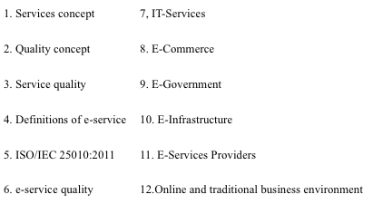

**Chapter 2.** Focuses on understanding concept of e-service and four considered dimensions for this thesis work: (1) Accessibility, (2) Usability, (3) Efficiency and (4) Security represented with acronym “AUES”.

**Chapter 3.** Conceptual model is presented, its components and the set of key e-service dimensional components as well.

**Chapter 4**. Applying proposed conceptual model to selected Estonian e-services.

**Chapter 5.** Discussion about results from experiencing with conceptual model on selected Estonian e-services.

**Chapter 6.** Results discussion, its interpretations, and set learning from the model and realizes its limitations when it is applied to Estonian e-services, future work and remaining questions are also presented here.

**Chapter 7.** Contains all the references used for this thesis work.

**Appendix** Contains a glossary with additional definitions in order to understand related terminology on this thesis work.

# The state-of-the-Art

The State-of-the-Art used in the thesis does mention about what has been understood as e-services during the years of 2001-2014 and what has been done related to them, for that purpose ten topics were considered for this chapter:

## Services

Since the beginning of human civilization provision of services has been important, especially on how those are delivered. When users get a product they do evaluations according to several factors, style, texture, tags, etc. But when services are purchased, aspects to evaluate become intangible (Parasuraman, Zeithaml and Berry, 1985) [1].

Services are intangible products such as accounting, banking, cleaning, consultancy, education, insurance, expertise, medical treatment, or transportation. No transfer of possesion or ownership takes place when services are sold, and they (1) cannot be stored or transported, (2) are instantly perishable, and (3) come into existence at the time they are bought and consumed[1].

A service is a means of delivering value to customers by facilitating outcomes that customers want to achieve without the ownership of specific costs or risks[2].

## Quality

There are several definitions and meanings for the concept of “quality” as discussed by Ojasalo (2006). Reeves and Bednar (1994) argue that, no universal definition of quality exists; there are different definitions appropiate for different circumstances. When quality is defined as coformance to specifications then objective and measurable standards are established [2]. Quality has been usually defined as meeting or exceeding customer expectations (Gronos, 1983; Parasuraman et al., 1985).

It is important to consider quality concept as the perception a customer has after receving the benefits or experiencing the performance of a service according to expectations based on previous experiences . The service provider can do efforts to give differentiated value through the offered service, but if the customer is not satisfied according to his perspectives, then quality is considered directly as low.

## Service Quality

In the context of services, quality is often understood as subjective customer perception.

One of the first models that allowed measuring the quality of services was created in 1985 as a conceptual model, in a study developed by Parasuraman, Zeithaml and Berry (1985) [1]. At the time, almost every service provided followed the traditional method, and literature and public conscience were not yet aware of the relevance of service quality [3].

Customer perceives quality as the result from how well expectations are met by experiences or performance given by the service. This is called disconfirmation (Gronroos, 1982; Parasuraman et al., 1988, Bitner, 1990, Bolton and Drew, 1991; Gummesson, 1991; Oliver, 1993).

Disconfirmation paradigm suggest that when the performance is at the same level as expectations, then service quality is good or excellent. If the performance is at lower level than expectations, service quality is inferior or bad [2].

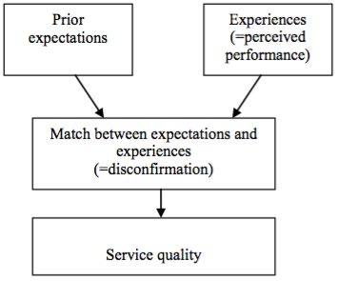

Disconformation & Service quality

Parasuraman et al. (1985) [1] identified five gaps (Figure 1), Gap 1 through Gap 4 on the part of the service provider (Marketer), and Gap5 on the Consumer part. These discrepancies emerged from the different perceptions held by the companies providing the services towards their job and by the consumers towards the quality obtained.

Each gap is described as follows:

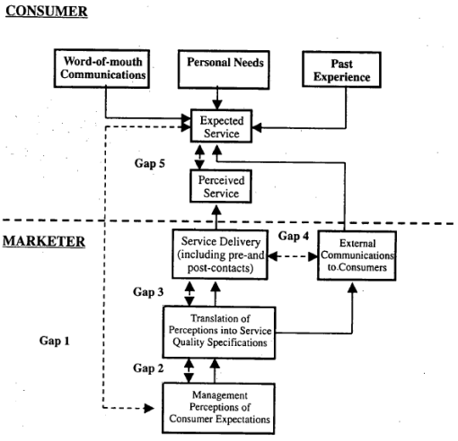

Figure 1. Service Quality Model

**Gap 1** – The different perspective of the consumer expectation and the perception of these expectations by the management/service provider, creates a gap and, consequently, a bad definition of service quality.

**Gap 2** – The difficulty or inability to clearly evaluate the perception of the managers when they create the specifications of the services.

**Gap 3** – The discrepancy between service quality specifications and the service that is actuallly delivered. Human factors and specifically the performance of the service provider, may generate a certain antipathy towards the defined standards.

**Gap 4** – The potential disparity between the provided and the communicated service. This disparity may alter the expectations of clients. The service provider should not offer more or raise expectations beyond the service that can actually be delivered.

**Gap 5** – The perception of quality that a consumer develops towards a service depends on the magnitude and direction of the gap between the expected and the experienced service.

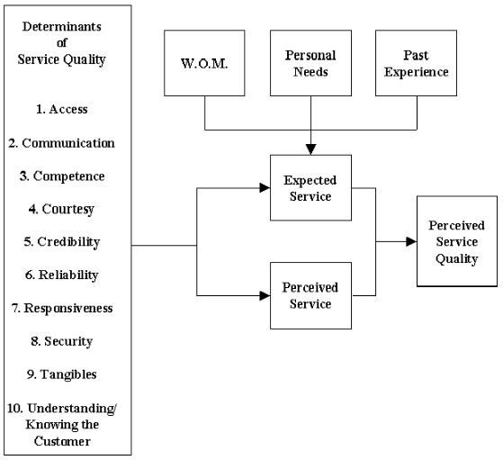

Figure 2. Perception of Service Quality

During model creation process in [1] they mention that the perception of service quality follows the comparison between the expected and the experienced service (Figure 2).

Services need to be described and understood in terms of both functional capabilities and service quality properties [4]. Service quality combines several service properties as security, availability, response time, etc., and generally are seen as distinctive success factors for service providers. Quality is used in order to define contract between a service user and the service provider, for having a guarantee that needs are meet.

On the other hand service quality has been defined as a set of non-functional attributes of contextual entities considered as relevant to the service-user interaction. Service quality could be classified as Quality of Execution (QoE) and Quality of Service (QoS) which can be measured for example with execution time, and are supported typically with Service Layer Agreements (SLAs). QoE does measurements in a subjective way, for example usability or reputation; both QoE and QoS give a perception to users.

According to Kritikos in [4], service quality can play significant role during several phases of the service life cycle. Security Quality Models are used to describe concrete properties regarding quality, and can be used by another quality document types to make use of service quality capabilities or requirements. It is worth to mention that the most common SLA components are (according to Paschke et al., 2006): contract validity period, involved parts, service definition and action guarantees. Service definitions specify the service characteristics, components and observable parameters.

It is generally agreed that service quality is multi-level and multi-dimensional concept that means different things to different people [5].

The need to evaluate quality turned into a success factor and service quality received a significant level of attention during the eighties, becoming a fundamental strategic differentiation factor in terms of market share and profit growth [3].

Based on [6] we remark eleven (11) important facts about Quality:

1. Quality is important prerequisite for success.
2. ISO, specifies three perspectives of quality: internal, external and in use.
3. Success on accuracy on content and useful services tailored to users according to their requirements.
4. Success factor is to warranty the levels of quality on software products.
5. It is no longer sufficient to simply provide technically excellent software products.
6. ISO defines several perspectives in order to analyze the level of quality.
7. Relevant literature has not dealt with quality in use in sufficient depth.
8. When users do not feel safety it is difficult for them to achieve their goals. If they are not satisfied they may easily decide to use another different solution.
9. Assessing the quality in use allows owners to estimate how usable a product might be and the satisfaction of the user.
10. To assess quality in use, it is first necessary to define a model, taking into consideration an ISO standard, for example.
11. Perception of quality in use must be measured in terms of results on using a software, not properties of the software itself.

According to Kritikos et al. (2013) [4] Service quality is a combination of several qualities or properties (e.g. availability, security, response time) of a service, and can be generally seen as an important factor in distinguishing the success of service providers. The service quality description is the main driver in selecting the best service among a set of functionally equivalent ones.

## Definitions of E-Service (Electronic-Service)

Ever since the dawn of civilization, human beings resort to other for the provision of services. These services vary from their most traditional format to modern day electronic services [3].

According to the Ruyter et al. (2001) an e-service is an interactive, content-centred and internet-based customer service driven by the customer and integrated with related organisational customer support processes and technologies with the goal of strengthening the customer-service provider relationship.

As stated in [7] an e-service is any asset that is made available via the Internet to drive new revenue streams or create new efficiencies. Amost any business asset can be turned into an e-service and efficiently offered via the Internet. E-services means openness, and openness means common standards.

In order to evaluate an e-service it is necessary to combine efficiency and effectiveness evaluation dimensions and measures from several existing frameworks, and adapt them to the particular objectives, characteristics, resources and capabilities of the particualer e-service [8].

As stated on [9], the information about an e-service may be presented as electronic description and policy, including it in a service directory or broadcasting it to all service consumers. There must be sufficient information about the e-service and the method for the consumer to interact with the service in such a manner and form that a potential consumer is aware of existence and capabilities of the e-service. It is also desirable if an on-line demo version for the e-service is available where customers could look and test the e-service on their own before they use it.

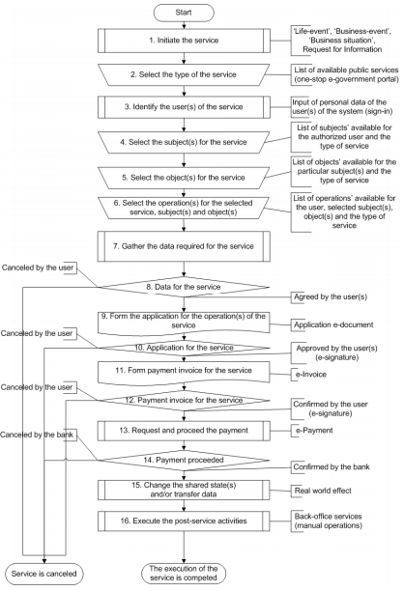

Figure 3. Procedure for a single e-service

Figure 3 shows the procedure of traditional e-service; e-services oriented to customer needs will impact positively organizations, which include the improvement of the organization performance and satisfaction on the clients [5].

E-services aim to offer to their users various electronic resources and capabilities to execute electronically various tasks and transactions. These include search for products and services, transaction with banks and government agencies, and acquisition of new knowledge and skills. Users can do these on a 24-h basis from their homes or offices [8].

## ISO/IEC 25010:2011 Standard

Accordign to [10], a working group of the International Organization for Standardization released in 2011 a reworked software product quality model stardard: ISO/IEC 25010 (which replaces its predecessor ISO 9126 restructuring and adding several parts of the quality models).

Quality models in this standard can be used to identify relevant quality characteristics that can be further used to establish requirements, their criteria for satisfaction and the corresponding measures. This standard can be used in conjunction with ISO 9001 (which is concerned with quality assurance processes) to provide:

* Support for setting quality goals
* Support for design review, verification and validation

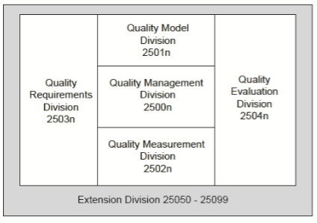

Figure 4. ISO/IEC Family Standards, taken from [10]

**ISO/IEC 2501n (in Figure 4)** – Quality Model Division. The international standards that for this division present detailed quality models for computer systems and software products, quality in use, and data. Practical guidance on the use of the quality models is also provided [10].

### Quality in use model

Quality in use model defines five characteristics related to outcomes of interaction with a system: Effectiveness, Efficiency, Satisfaction, Freedom from risk, and Context Coverage (Figure 5).

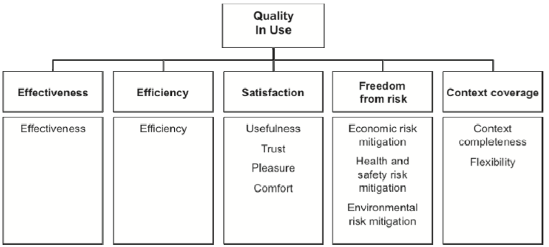

Figure 5. Quality in Use model, ISO/IEC 25010:2011, taken from [10]

As stated in [10] the quality in use of a system characterizes the impact that the product (system or software product) has on stakeholders. It is determined by the quality of the software, hardware and operating environment, and the characteristics of the users, tasks and social environment. All these factors contribute to the quality in use of the system.

### Quality product model

The product quality model categorizes system/software product quality properties into eight characteristics: functional suitability, performance efficiency, compatibility, usability, reliability, security, maintainability and portability. Each characteristic is composed of a set of related subcharacteristics (Figure 6).

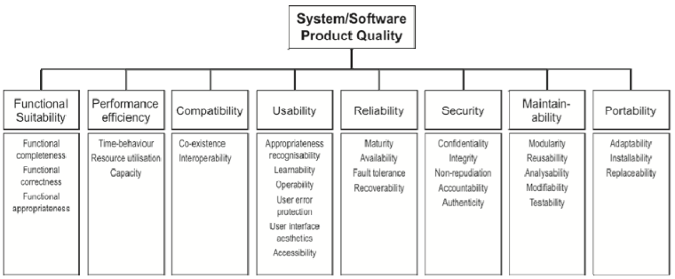

Figure 6. Product Quality, ISO/IEC 25010;2011, taken from [10]

As stated in [10], the product quality model can be applied to just a software product, or to a computer system that includes software, as most of the subcharacteristics are relevant to both software and systems.

## E-service Quality (e-SQ)

The concept of e-service quality (e-SQ) is derived from the quality of traditional services [11]. According with Teimouri et al. [12] in the past, term of service quality was one of the key factors for succes on unit. But now with the rapid growth of online businesses, this term has begun to call as e-service quality which shows the quality of services in electronic business and marketing.

e-SQ has increasingly attracted the attention of researchers after the year 2000, the existing research on this area is mostly focused on identifying quality dimensions of e-services without any deeper attention to the mechanism that explains quality perception [2]. According to Ateeq, Kamil and Basri in [11] e-SQ can provide organization competitive advantages in the online environment.

e-SQ is defined as the overall consumer evaluations and opinions regarding the excellence of e-service delivery in the virtual marketplace [5]. Collier and Bienstock claimed that e-SQ refers to the perception of the user of the outcome of the service delivery along with service recovery perceptions, if service failures happened [13].

The e-SQ can affect the success of online businesses. This can potentially increase attractiveness, hit rate, customer retention, stickiness, and positive word of mouth and can maximize the online competitive advantages of e-commerce [5].

Many researchers are conducted to measure e-SQ, but no inclusive scale has been developed defining the dimensions and the attributes properly. This leads to confusion when organizations are trying to improve e-services [14].

Different authors have defined dimensions for evaluation the e-SQ as Zeithaml et al. (2001) defined eleven dimensions (Flexibility, Reliability, Access, Ease of navigation, Efficiency, Responsiveness, Personalization, Assurance/Trust, Site aesthetics, Price knowledge, and Security/Privacy) [15], Cox and Dale (2001) defined 6 dimensions (Website appearance, Accessibility, Communication, Credibility, Availability and Understanding) [16], Yang et al. (2003) posposed eight dimensions (Prompt delivery, Credibility, Ease of use, Reliability, Convenience, Communication, Accessibility and Competence) [17], Raman et al. (2008) proposed six dimensions (Appearance, Ease of use, Customization, Reliability, Communication and Incentive) [18].

Some other author have defined measurement instruments with dimensions, Parasuraman et al. (2005) developed E-S-QUAL with four dimensions (Efficiency, Availability, Fulfillment, and Privacy), Yoo and Donthu (2001) developed SITEQUAL with four dimensions (Ease of use, Aesthetic design, Processing speed, and Interactive responsiveness), Wolfinbarger and Gilly (2003) proposed eTailQ with four dimensions (Reliability, Website design, Security and Customer service) [19], Lociacono et al. (2002) developed WEBQUAL composed of twelve dimensions (Information, Visual appeal, Response time, Interaction, Trust, Design, Intuitiveness, Innovativeness, Flow-emotional appeal, Integrated communication, Business processes, and Substitutability) [20] and [21], Bressolles (2008) developed NetQual with five dimensions (Information, Ease of use, Reliability/fulfillment, Security/privacy and Site design) [22].

Table 1 shows six common instruments and their dimensions for evaluating the quality of e-services.

Table 1. e-SQ measures and their dimensions, taken from [40]

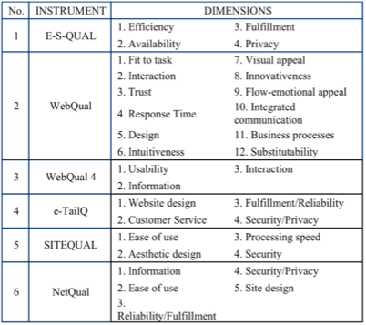

In general, the literature indicates that five dimensions are repeated systematically: (1) Information, (2) Website design, (3) Ease of use, (4) Security/privacy and (5) Reliability [23]. Eventually all the scales and measurements are different in their dimensions and attributes. On the other hand most researchers have focused on limited variables set instead of a full view of e-SQ [14].

Some researchers utilized the conventional SERVQUAL scale to measure e-services quality, but, it has been found inadequate in evaluating e-SQ. This is because e-service varies from traditional service in three aspects: (1) Sales staff absence, (2) Lack of conventional tangible element and (3) Customers self-service. In view of this, it is obvious that the SERVQUAL is not adequate for measuring the quality of e-service, and it is necessary to develop a tool for measuring e-SQ [24] and [25].

Available methodologies need to be capapable of measuring services not only in their traditional format but also in their electronic dimension [3].

Companies can use e-service quality as a competitive advantage in competitive marketplace. High e-service quality provide long-term benefits to a company [5].

All in all, there is a variety of e-service quality dimensions that have positive and significant impacts of perceived quality on online users [26].

Accurate measurement of the e-SQ is a complex process due to the nature of the service because it is immaterial. It has been indicated through the literature that there is a lack of universal set of definitions, model and dimensions for service quality measurement [27].

Many online organization businesses became unsuccessful due to poor e-service quality [26]. In order to make the assessment process easier, the quality in use model defined in ISO/IEC 25010 [28] defines three main characteristics: Usability Safety and Flexibility.

## IT-Services

An Information Technology Service (IT-Service) is a ready-to-use deliverable that is of value to the customer, allowing to do business without worrying about underlying technology or Information Technology infrastructure[3].

A quality measurement framework focused on IT-Service concept is useful when organizations take into consideration the linked interactions between their measures and corresponding evaluation, this due the understanding of the interrelated work among a system elements is important to aware how other elements are affected [29]. This approach is not applicable when organizations consider each system element as isolated and completely separated units. Measurement elements could be used in order to understand improvements and quality on services in three different contexts: simple, complicated and complex.

Based on [4] and [29], five (5) important facts about IT-Services are considered:

1. Quality on IT Service is highly dependent on the expectations from customers.
2. IT Service quality measurement framework is intended to understand the various dimensions of IT Service Quality.
3. When service providers attempt to standardize operations and make processes replicable the service providers often look their organizations as separated units instead of the entire system.
4. Continuous improvement on quality of services increases customer satisfaction, this is vital for companies in order to survive on the market. Nowadays quality has become important and recognized, nevertheless, what remains understudied are both its concrete conceptualization and measurements.
5. Comprehensive view of the quality of service offering on both intrinsic and extrinsic quality attributes that contributes to customer satisfaction is necessary.

As stated on [29], more and more services are based on or use information technology but research into the quality of the interdisciplinary field of IT services is similarly understudied. A number of service science researchers have identified the need to focus on service quality measurement and improvement (Chesbrough and Spohrer 2006; Ostrom et al. 2010; Rush 2004).

## E-commerce

The rapid development of social media and Web 2.0 has provided a huge potential to transform e-commerce from a product-oriented environment to a social and customer centred one (Wigand et al. 2008) [30].

Online environment has the power of “fast shifting” to consumers in order to switch to a new provider with a click of a mouse. Online customers expect fast, friendly and high quality service. According to Zhao and Gutierrez (2001) users want choice, convenience, and a responsive service with special touch.

E-commerce is widely considered as the buying and selling of products over the Internet, but any transaction that is completed solely through electronic measures can be considered as e-commerce. E-commerce has been defined as the buying and selling of products and services by businesses and consumers through an electronic medium, without using any paper documents. E-commerce is subdivided into three categories: Business to Business or B2B (for example Cisco Networks), Business to Consumer or B2C (for example Amazon), and Consumer to Consumer or C2C (for example eBay)[4].

Companies need to focus on e-services supported by appropriate technology in order to maintain customers, improve operational efficiencies and boost revenues from e-commerce. In a market where there are so many players, companies need to be customer-centric. Success for a company is measured by how effectively it interacts with its customers. Service quality is one of the key factors in determining the success or failure of e-commerce [12]. Service quality is critical principle in e-commerce design [30].

Liu and Arnett (2000) in [30] consider five different aspects:

1. E-commerce should make customer enjoy their visit
2. It should motivate customer to feel engaged
3. It should promote the excitement of the customer
4. It should offer aesthetic design to attract customers
5. It should promote the concentration of customers when they shop online.

Table 2 shows the common dimensions and consistent dimensions to evaluate the service quality in e-commerce.

Table 2. Common dimensions to evaluate e-SQ in e-commerce

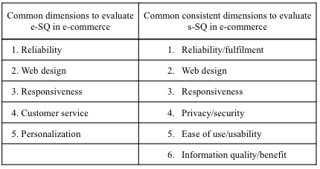

For example ‘Reliability’ which is one of the key dimensions of the offline context is reported in numerous e-SQ scales. ‘Responsiveness’ which is one of SERVQUAL dimensions is also reported in several studies of e-SQ, but the interpretation of ‘Responsiveness’ dimension is different in web-based context from its connotations in the traditional interpersonal service environment [31].

Two of the dimensions that are seen in most of studies are ‘Reliability’ and ‘Ease of use’ which shows that customers determine this dimensions in evaluating e-service quality regardless of type of service. But other dimensions are important in specific context and services.

Important points about e-commerce are:

1. A proactive strategy to develop and implement e-services is important requirement in B2C e-commerce.
2. Adopting new technologies to offer e-services to help, to assist customers during search process, comparison-shopping, to find quick answers, etc., and assure trust and secure transaction, lead to get more customers.
3. Applying new tools and techniques can increase e-Services quality.
4. To increase customer base in e-commerce it is important to implement and continuously review the quality of e-services.
5. It is important to identify the value of each e-service in B2C e-commerce.

## E-government

As mentioned in [11] e-government has been introduced by many governments with attempt of increasing effectiveness and efficiency. For example, citizens and businesses can get information about government policies and regulations and apply for government benefits from anywhere at any time by using e-government services. E-government can be used as a tool to improve the transparency of government, leading to more accountability and less depravity. In [32] is mentioned the successful rate of e-governement projects has been estimated to be low, approximately 35% of e-government projects in developing countries are failed; almost 50% are partially failed, and only 15% are successful. Studies in e-commerce domain indicate that the lack of electronic services quality (e-serice quality) can cause the failure of projects [5,33] and [34].

E-government service portals need to understand user needs more than government's perspectives or interests. This is a challenge, that's why to have standardized framework makes architecture of government service portals clear. According to Sarantis, D., et al. (2009) standard frameworks for electronic governments service portals are still in early age; available technologies are used on advanced profitable products. Considered potential and capabilities of having an applicable, sustainable and ever-expanding framework are guidelines (of the framework), to design, development and operation of portals in central, regional and other levels of government.

A general accepted definition for government portal and its characteristics definition, is still pending, therefore concept of a portal has not yet been standardized and as a result each entity which implements their own designs, set its own functionality and technical specifications and put own needs before other more important, which are from customers, and citizens.

There are implemented e-government services which are not well-designed or not promoted with agencies that provide them.

Based on [35] we consider seven (7) important facts about e-government:

1. Users expect quality services, the online dimension is no exception.
2. Quality of services should be analysed and accounted for, in order to maximize and to develop strategies that improve offered services, increasing the satisfaction levels of their consumers.
3. A consumer will always evaluate the service on several factors.
4. The perspective of user concerning the quality of the service is fundamental to measure satisfaction.
5. It is important to have a model to measure quality of services.
6. A one-stop-shop entry point to government information and services is a significant advancement in the maturity of e-government.
7. E-government services are not either well designed or not suitable promoted.
8. Difficulty to find needed information and services, complexity to access and use of e-services, the need for a better help regarding the e-service provided on the web site, and the content understandability are some issues that might create the need of a quality of e-government service [36].

Generally, e-government service quality refers to the degree to which an e-government website could facilitate the competent delivery of efficient e-services to help citizens, businesses and agencies in achieving their governmental transactions [37].

It is believed that the success of governmental organizations will depend on the quality of e-government services provided to citizens. Therefore, by understanding the dimensions of quality e-government services enhancing satisfactionson users and gaining user trust, government service managers and governmental organizations should be able to reduce some risks (e.g. investing valuable resources in e-service quality characteritics that may not work effectively) [11].

Interoperability in e-government has been recognized as key factor in the quest for administrations at national, local and international level to achieve the provision of one-stop services to citizens and businesses (Charalabis, Panetto, Loukis, & Mertins, 2008).

Interoperability in e-government shoud enable efficient information exchange between applications from different agencies in order to provide high quality services to both, businesses and citizens.

Success in e-government requires agencies to work together across traditional boundaries to improve services significantly and to reduce operating costs. This implies that different applications have to be able to exchange information (current problematic) [33] therefore, e-infrastructure plays an important role on creating a context where different virtual entities can work together in order to provide e-services.

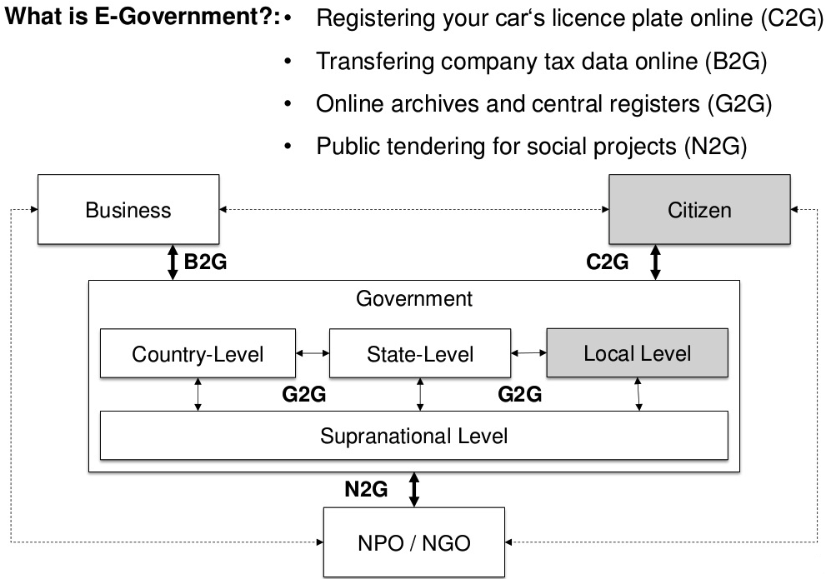

e-services examples related to e-government[5]

## E-infrastructure

Deployment of information systems over the last 30 years has resulted in the need for opening up and connection closed applications. Such an interoperable, networked and heterogeneous structure is called information infrastructure [33]. E-infrastructures usually take place when various applications merge allowing dissimilar applications to be linked into networks. E-infraestructure design never starts in a green-field situation, this means that the central problem is how to integrate existing applications, which are locally controlled by different organizations into an interoperable distributed e-infrestructure of IT capabilities, there is no concrete way to accomplish this. E-infraestructures are not designed by an omnipotent design and the e-infraestructre emerges from growth.

Based on [33] we consider five (5) important facts about e-infrastructure:

1. Interoperability should enable efficient information exchange between applications from different agencies with help of IT-Services.
2. Interoperability is accomplished by e-infrastructure. Knowledge of how to develop e-infrastructures in the public sector is still limited.
3. The initial problem of starting-up development of e-infrastructure is bootstrapping.
4. Success in e-government requires working together across traditional boundaries to improve services significantly and to reduce operating costs.
5. Central problem is how to integrate existing applications, which are locally controlled by different organizations into an interoperable distributed e-infrastructure of Information Technology (IT) capabilities (Edwards et al., 2009). How to accomplish this is still limited.

The appropriate technological infrastructure plays a crucial role towards achieving higher levels of trustworthiness [38].

## E-services Providers

Around trust and trustworthiness there have been several researches. As described in [38], continuous growth of e-services economy is a trigger for stakeholders to adopt trustworthiness as critical component on offered e-services. Eight elements fundamental for trustworthiness of e-services are identified: (1) The service personnel, (2) Information and communication, (3) Technology, (4) Policies and plans, (5) Service level agreements, (6) Privacy, (7) Accountability, and (8) Third party.

According to Ostasius, E., & Petraviciute, Z. (2010), there should be a developed tool for the quantitative assessment of trustworthiness, having two parts, one for evaluating the e-service provider and another part to assess the e-service provider from the user's perspective [9].

Different maturity, complexity and rapid growth of new e-services promote assessment and comparison with each other [9]. Talking about services for the public sector, there is a model, which assist authorities to evaluate maturity and complexity level of provided e-services. Some studies with their methodologies of measuring sophistication level have ranked countries for e-government implementation; they bear basic features in common and are based on the stage models of sophistication.

Based on [9] we remark fourteen important points about e-services providers:

1. Assessment and comparison on new e-services takes place as the number of new e-services growth.
2. Having a model is useful on evaluating the maturity and complexity of e-services.
3. A model has to have measures on its methods.
4. On evaluating e-service, main aspects and characteristics should be identified.
5. The higher sophistication level means the higher maturity of the e-service, the higher sophistication causes the higher service level.
6. Evaluation of e-service maturity means also the evaluation of the system complexity.
7. For construction of the evaluation criteria is recommended to use Model for Service-Oriented Architecture, service categorization, and elements of the e-service model.
8. It is important to consider a quantitative assessment of the trustworthiness level of e-service provider.
9. There are eight fundamental elements affecting the level of trustworthiness of e-service: service personnel, information and communication, technology, policies and plans, service level agreements, privacy, accountability and third party.
10. Result of assessment indicate areas of weakness and strengths.
11. Measures of performance, productivity and success have to be related to the degreee of service users trust and satisfaction with the provided services.
12. Organizations have to be aware of ethical responsibilities associated with offered services.
13. A trustworthy service must: be secure, preserve and respect the privacy concerns of its users, be reliable, and be delivered with the highest business integrity.
14. A secure service preserves and enforces the confidentiality, integrity and availability of information while in storage, or being processed or transmitted.

For online suppliers e-service quality can create distinctiveness, and this is specially useful for small companies [5].

## Online and traditional business environments

The differences between online environment and traditional business units [31]:

* **Convenience and efficiency**: consumers using the online environment have the convenience of saving time and effort in comparing the price or technical features of products more efficiently [5].
* **Safety and confidentiality**: online environment involves users in distinctive issues regarding privacy, safety and confidentiality.
* **Absence of face-to-face contact**: absence of person to person interaction means traditional concepts and ways of measuring service quality are inadequate when applied to e-service quality.
* **Co-production of service quality**: online environment gives the customer prominent role in co-producing the delivered service [39].

## Chapter summary

There are different definitions for e-service, but no e-service concept definition has been stated as reference, specially one which defines e-service in terms of Accessibility, Usability, Efficiency and Security.

The literature indicates a lack of global set of dimensions for measuring e-SQ [27]. Researchers used various dimensions and proposed different quality measurement instruments for e-SQ (Chapter 1-Part 6, Table 1), but those different dimensions are subject to change based on researches studies [40], all of them are reinventing the wheel and suggesting different ways how to do the same “Quality of e-services should be evaluated or meassured according to ‘A’ or ‘B’ approach”. Yang et al. (2003) indicated that e-SQ dimensions tend to be dependent on various industries and different service types even within same industry [17]. Moreover, there are no concrete models suggesting minimum dimensions with specific key components for understanding the qualitative characteristics of e-services which could be considered as reference point.

E-services quality characteristics have been studied during previous decades but, no model has been proposed considering both quality in use model and product quality model described within ISO/IEC 25010 standard. A quality in use model for web portals was proposed in [6], defining three main characteristics about quality: Usability, Safety and Flexibility, which was based on the version of year 2009, however, ISO/IEC 25010:2011 suggests different characteristics: Effectiveness, Efficiency, Satisfaction, Freedom from risk, and Context Coverage (Chapter 1, Part 1.5).

In Chapter 1, Part 1.3, Gap 1: Differences between cosumer and provider perspectives expectations contribute to bad quality definition; Gap 3: The discrepancy between service quality specifications and the service that is actuallly delivered, and Gap 5: Consumer quality expectation increases or decreases based on previous experiences, are gaps that are part on e-services contexts.

Due business expansions and new business opportunies there have been developed many kind of e-services on different sectors and industries during last decades, giving place to difficulties on infrastructure for integration purposes, limitations for satisfying customers on e-commerce, and users with bad quality perception on e-governance solutions. Besides lack of representation about e-services domain and based on performed systematic literature review (which considers studies from 2001 until 2014), a domain model for e-services is depicted in Figure 7.

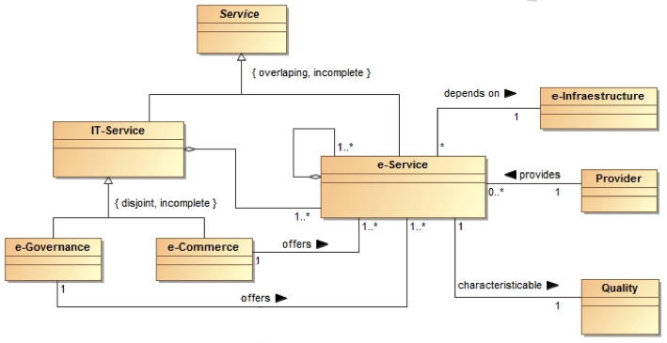

Figure 7. E-services State-of-the-Art domain model

No schema, representation, or description about how e-services could be efficiently used accessed and utilized has been proposed yet. Accurate measurements of the e-SQ is a complex process and there is a lack of universal definition, model and dimensions for e-SQ measurement [40].

# The e-service concept and four dimensions

On this chapter, four (4) dimensions considered for this thesis work are proposed Accessibility, Usability, Efficiency and Security (AUES), and a concept definiton of e-service in terms of AUES. An hypothesis for each dimention was set in order to establish a conclusion in Chapter 5 as result of applying proposed conceptual model (Chapter 4) to selected Estonian e-services in Chapter 4.

## Four dimensions for e-services (AUES)

It is referenced on [8] that despite the high investments that have been made for setting up and running e-services, for most of them, usage is below expectations and users are not satisfied with their quality (European Commision 2008, sumak et al. 2009), so they need improvements in order to reach higher levels of maturity.

Many e-services have been developed and are currently used by individual and organizations, however their usage and quality typically are below the expectations of users. Diversity on businesses has created a different kind of e-services, therefore is common to find different dimensions to understand e-services quality.

Four dimensions are proposed in this thesis work for understanding the quality of e-services (AUES): Accessibility, Usability, Efficiency, and Security, shown in Figure 8.

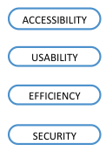

Figure 8. Four Quality dimensions for e-services

AUES dimensions consider its basis and relevance on e-SQ instruments (Table 3) and e-SQ approaches (Table 4), as described in Chapter 1-Part 6 (e-SQ).

Table 3. Attributes within e-SQ instruments for AUES dimensions

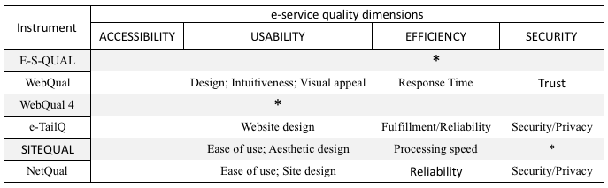

Table 3 shows how different e-SQ instruments consider each dimension, for example E-S-QUAL consider Efficiency as dimension, WebQual considers Design, Intuitiveness, and Visual appeal dimensions as we understand Usability as dimension.

Table 4. Attributes within different approaches for AUES dimensions

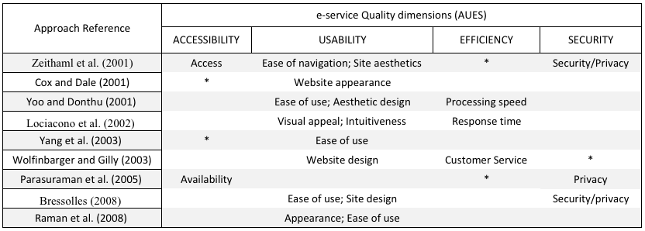

Accessibility dimension was not considered on any of the e-SQ instruments (Table 3), however, it was considered by Cox and Date (2001) and Yang et al. (2003) as dimension, although Zeithaml et at. (2001) and Parasuraman et al. (2005) considered accessibility with another term (Access and Availability respectively) in Table 4.

Definitions for each dimension and hypothesis for each one are as follows:

### Accessibility dimension

Degree to which a product or system can be used by people with the widest range of characteristics and capabilities to achieve a specified goal in a specified context of use [10]. To communicate its existence to users is part of this dimension.

**H.A.**: Accessibility dimension positively influences customer satisfaction.

### Usability dimension

According to Yoo and Douth in [41], ease of the site usage is one of the most significant elements that have influenced online satisfactions and behaviours on online users. The complexity to use or consume an e-service might emerge dissatisfaction and respectively decrease the trust of users leading them to search for alternatives.

**H.U.**: Usability dimension positively influences customer satisfaction.

### Efficiency dimension

Two of the most important reasons for users to do their online transactions are convenience and time saving [42]. The efficiency dimension will play a substantial role in achieving the goal of providing fast and convenient access to information and services [11].

**H.E**.: Efficiency dimension positively influences customer satisfaction.

### Security dimension

Security encompasses low risk associated with online transactions, safeguarding personal information, and safety in completing online transactions [12].

Security is the degree to which the customer believes the sie is safe from intrusion and personal information is protected [43].

**H.S.**: Security dimension positively influences customer satisfaction.

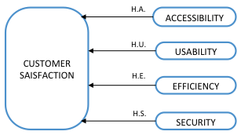

Figure 9. AUES hypothesis influence on customer satisfaction

Proposed AUES quality dimensions on this chapter will be related to a quality in use model and product quality model on next chapter based on ISO/IEC 25010:2011 [10].

## Electronic service definition

We propose definition for electronic service concept in terms of AUES dimensions (Figure 8) as:

**E-service** an asset to deliver services (with one or more capabilities) via the Internet, provided by an entity called the service provider to drive reliable effiencies and functionalites with convenient access, interacting or not with other e-services for building new ones and for doing secure online transactions safeguarding the privacy and information related to its users, with significant elements to have the minimum complexity for its use in any of the business schema transactions, B2B, B2C or C2C.

Quality perceived from e-services should be through properties the user has as result of using it, and not based on characteristics which describe the e-service [6].

Next chapter contains all the elements necessary to construct a conceptual model for understanding quality of e-services based on its qualitative characteristics.

# Conceptual model to understand quality of e-services

On this chapter, a quality in use model and a product quality model based on ISO/IEC 25010:2011 stardard are defined in order to stablish an understanding how the quality perceived by e-service user and quality perceived by the e-service provider are related to each other.

## Quality in use model for e-services

Quality in use model characterizes the impact e-services have on users to meet their needs to achieve specific goals with effectiveness, efficiency, freedom from risk and satisfaction in specific contexts of use [10].

The perception of quality in use must be measured in terms of the result of using the software, rather than the properties of the software itself [6].

In order to propose a set of attributes for a quality in use model, following question was considered:

**Q.A**: What are the qualitative characteristics of an e-service from the user perspective?

Based on the fact that online customers expect fast, friendly and high quality e-services, the attributes for quality in use model, meant to answer **Q.A** are Convenience, Performance, Trustworthiness, and Compatibility (Figure 10):

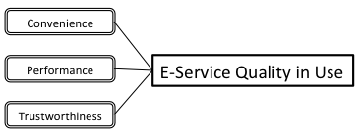

Figure 10. Proposed e-service Quality in use model

We define the e-service quality in use model components as follows:

**Convenience** refers to degree of usefulness an e-service provide to its users.

**Performance** refers to how an e-service provides responce and processing times when by performing its functions, meet requirements of users.

**Trustworthiness** degree of reliability to respect and preserve the privacy concerned to e-service users.

The quality in use model contains the characteristics that users will perceive as quality influencing properties as result of using an e-service.

## Product quality model for e-services

According to [6] the main purpose of a software quality model is to specify the level of quality of a product through internal measures of inherent properties of the software, and through external measures of the behavior of the systems of which the software is part.

In order to propose a set of attributes for a product quality model, the following question was considered:

**Q.B**: What are the quality characteristics of an e-service from the provider perspective?

The attributes for product quality components, meant to asnwer **Q.B** are: Compatibility, Funcionality, and Reliability, depicted in Figure 11.

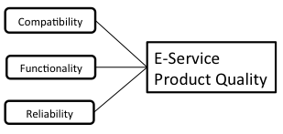

Figure 11. Proposed e-service Product Quality model

We define the e-service product quality model components as follows:

**Compatibility** degree to work or share information with other e-services of same type in which an e-service can be used in building new e-services regardless the hardware for software environment.

**Functionality** refers to the functions and availability of the e-service.

**Reliability** ability to perform the promised service dependably and accurately [12]. Reliability is a significant determinant of overall service quality, satisfaction, perceived value, intention to use and re-use intentions [31]. In online services, it is important to ensure trust that service provider keeps his promises. Reliability can make users realize the consistency of services providers and credibility as well [24].

## Quality in use model and AUES dimensions

Figure 5, shows both the quality in use model (Chapter 4, Part 1) and the four proposed AUES dimensions (Chapter 3, Part 1), where relationships between the e-service Quality in use model components and AUES dimensions are shown.

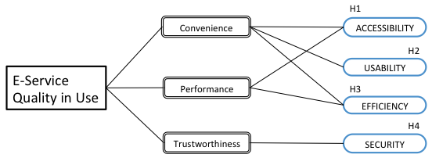

Figure 12. Relationships between quality in use model and AUES dimensions

We support relationships shown in Figure 12 with following hypothesis which complement hypothesis shown in Figure 9:

**H1**: Accessibility quality dimension contributes to quality perceived by user through Convenience and Performance qualitative characteristics.

**H2**: Usability quality dimension contributes to quality perceived by user through Convenience qualitative characteristic.

**H3**: Efficiency quality dimension contributes to quality perceived by user through Convenience and Performance qualitative characteristics.

**H4**: Security quality dimension contributes to quality perceived by user through Trustworthiness qualitative characteristic.

The quality in use model contains the characteristics in which e-service users will be focused to perceive quality on e-services.

## Quality product model and AUES dimensions

Figure 13 shows the quality product model (Chapter 4, Part 2) and and the four proposed dimensions (Chapter 3, Part 1), where relationships between the e-service Product Quality Model components and AUES dimensions are depicted.

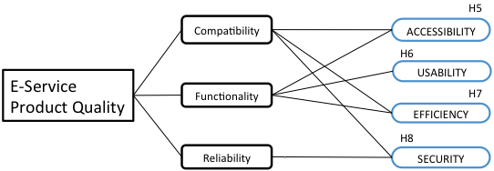

Figure 13. Relationships in product quality model and AUES

We support relationships shown in Figure 13 with following hypothesis which complement hypothesis shown in Figure 9:

**H5**: Accessibility quality dimension contributes to quality provided to user through Compatibility and Functionality qualitative characteristics.

**H6**: Usability quality dimension contributes to quality provided to user through Functionality qualitative characteristic.

**H7**: Efficiency quality dimension contributes to quality provided to user through Compatibility and Functionality qualitative characteristics.

**H8**: Security quality dimension contributes to quality provided to user through Compatibility and Reliability qualitative characteristics.

The product quality model contains the characteristics in which e-service providers will be focused to provide quality on e-services.

## Quality in use, Product quality models and AUES dimensions

Considering Figure 12 and Figure 13, a combination of quality in use model and product quliaty model depicted on Figure 14 suggests relationships with AUES dimensions, a series of hypothesis are on next section which are meant for supporting aforementioned relationships.

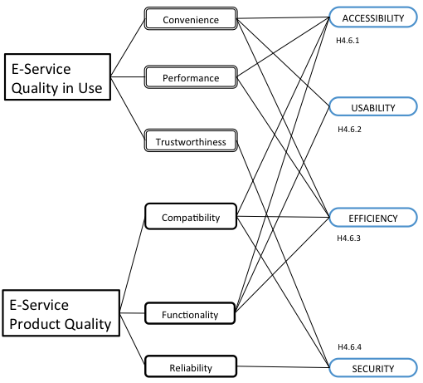

Figure 14. Quality in use, Product quality and AUES

Table 5 aids to understand relationships between e-service qualitative characteristics (quality in use, product quality models) and AUES quality dimensions.

Table 5. Relationships between e-service qualitative characteristics and AUES quality dimensions

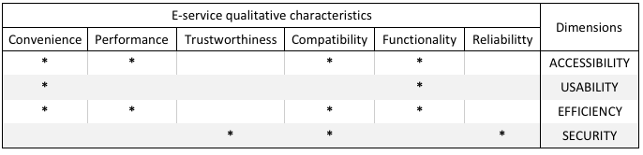

## Hypothesis on e-services AUES dimensions and Qualitative characteristics

**H4.6.1**: Degree of Accessibility quality dimension contributes directly but independently to Convenience, Performance, Compatiblity, and Functionality qualitative characteristics.

**H4.6.2**: Degree of Usability quality dimension contributes directly but independently to Convenience, and Functionality qualitative characteristics.

**H4.6.3**: Degree of Efficiency quality dimension contributes directly but independently to Convenience, Performance, Compatibility, and Functionality qualitative characteristics.

**H4.6.4**: Degree of Security quality dimension contributes directly but independently to Trustworthiness, Compatibility, and Reliability qualitative characteristics.

Aforementioned hypothesis are depicted on Figure 14.

## AUES and key e-service dimensional components

As mentioned in Chapter 2, Part 6, different authors have suggested different dimensions and components, meant to evaluate the quality on e-services, Table 5 shows the suggested quality dimensional key components (Figure 15) considered on those studies including the product quality model from ISO/IEC 25010:2011 [10], there are some studies which consider some of our key dimensional components with a different term.

Figure 15 shows four AUES dimensions (Chapter 3, Part 1) with a set of proposed components for each dimension.

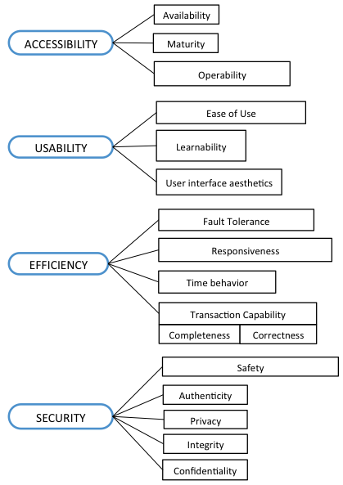

Figure 15. AUES dimensions and their key components

Table 6. Suggested quality dimensional key components and Approach References

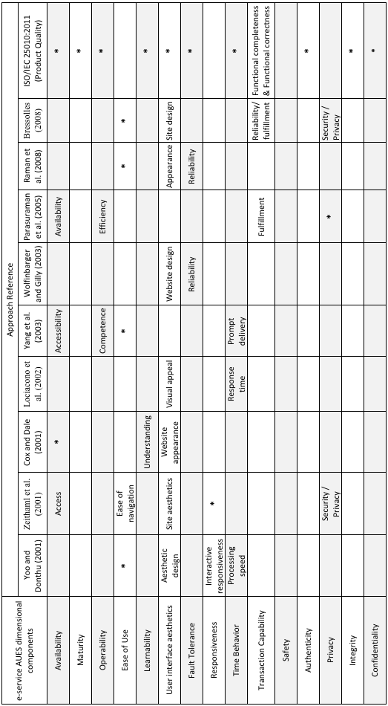

### Accessibility key components definitions

* **Availability** enables continuous access to online service and enhances loyalty on users [44]. If users cannot use the online system on their need to get online service, they will leave the site [24]. Ensuring the technical function may increase user satisfaction [42].
* **Maturity** degree to which a system or component meets needs for reliability under normal operation[6].
* **Operability** degree to which a system has attributes that make it easy to operate and control6.

### Usability key components definitions

* **Ease of use** moderate efforts required for completing online transactions [45]. Internet-based transactions might seen complex and intimidating to customers, it is reasonable to expect the ease of use to be determinant of perceived e-service quality [43]. Yoo and Douthu (2001) indicated that ease of use is a significant element that affect the satisfaction of the online user [41].
* **Learnability** degree to wich a product can be used by specified users to achieve specified goals of learning to use it with effectiveness, efficiency, freedom from risk and satisfaction in a specified context of use7.
* **User interface aesthetics** degree to which a user interface enables pleasing and satisfying interaction for the user7.

### Efficiency key components definitions

* **Fault tolerance** degree to which a system operates as intended despite the presence of hardware or software limits[7].
* **Responsiveness** handling of problems effectively and responding to users in online environment, can increase the satisfaction of users [24]. Online users expect the organization to punctually respond to their inquiries [46]. Lee and Lin stated that many studies showed a remarkable correlation between responsiveness and satisfactions on users [26].
* **Time behavior** degree to which the response and processing times and throughput rates of a system, when performing its functions, meet requirements[8]. Obi claimed in [47] that lengthy process times may affect user satisfaction, user trust, and productivity negatively.
* **Transaction Capability** set of communication capabilities that provide an interface between applications and a network layer service. Degree to provide the means for the transfer of information between nodes, and to provide generic services to applications, while being independent of any of those [48]. This particular component is composed of the following subcomponents to work with other e-services or applications:
  + **Completeness** degree to which the set of functions covers all the specified tasks and user objectives[9].
  + **Correctness** degree to which a product or system provides the correct results with the needed degree of precision9.

### Security key components definitions

* **Safety** attribute of a system that will not incur in any catastrophic failures in the interval of time when an e-service is in use [10], (freedom of risk).
* **Authenticity** degree to which the identity of a subject or resource can be proved to be the one claimed[10].
* **Privacy** degree to which an e-service protects customer information [43] and refers to companies not sharing information with third parties unless the customer gives permission [12]. This includes providing visual symbols so customers know a secure connection is being achieved [13].
* **Integrity** degree to which a system or component prevents unauthorized access to, or modification of data10.
* **Confidentiality** degree of which a system ensures that data are accessible only to those suthorized to have access10.

## Hypothesis on AUES Key dimensional components

Seven hypothesis based on proposed influences among the AUES key dimensional components are shown in Figure 16, which are meant to support the qualitative characteristics of e-services (Quality in use model, Chapter 4, part 1) throughout AUES quality dimensions (Chapter 3, Part 1).

### AUES key components hypothesis series

**H4.8.1**: Operability contributes to degree of Maturity component.

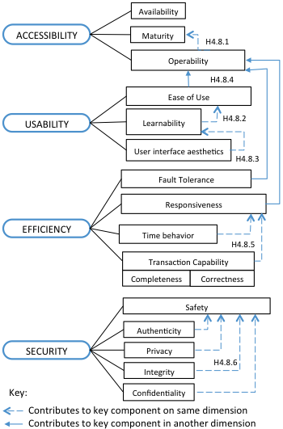

Figure 16. Influences among AUES key dimensioinal components

**H4.8.2**: Learnability contributes to degree of Ease of use component.

**H4.8.3**: User interface aesthetics contributes to degree of Learnability component.

**H4.8.4**: Fault Tolerance, Responsiveness, and Ease of Use contribute directly but independently to degree of Operability component.

**H4.8.5**: Time behavior and Transaction Capability (Completeness and Correctness) contribute directly but independently to degree of Responsiveness.

**H4.8.6**: Authenticity, Privacy, Integrity, and Confidentiality contribute direcly but independently to degree of Safety.

## Conceptual Model

By means of Quality in Use model (Chapter 4, Part 1), Quality Product model (Chapter 4, Part 2), proposed AUES Quality dimensions (Chapter 3, Part 1) with their key components (Chapter 4, Part 6), and based on ISO/IEC 25010 standard (Chapter 2, Part 5) the conceptual model on Figure 17 proposes six qualitative characteristics for understanding the quality of e-services in AUES dimensions.

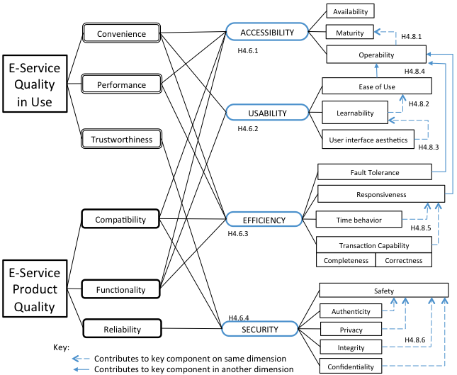

Figure 17. Conceptual model for understanding qualitative characteristics of e-services

Conceptual model for understanding qualitative characteristics of e-services

Table 4 in section 4.5 can be used in order to have a clear understanding on how relationships between qualitative characteristics and AUES qualitative dimensions are.

On next chapter proposed conceptual model for understanding characteristics of e-services will be applied in order to test how effective it could be.

## Conceptual model dependability

According with dependability definition in [10], which states that dependability characteristics include Availability, Reliability, Security (including Confidentiality and Integrity) with their inherent factors (Safety and Trustworthiness), the dependability models for proposed conceptual model for understanding qualitative characteristics in previous section (4.9) is depicted in Figure 18 and Figure 19 respectively, those figures represent the extracted elements from conceptual model form Figure 17.

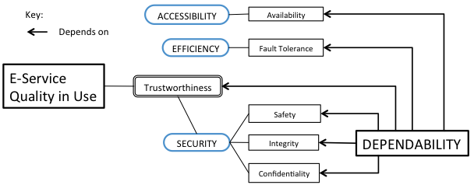

Figure 18. Dependability model for Quality in use model

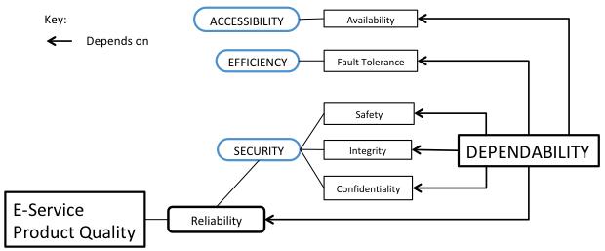

Figure 19. Dependability model for Product Quality model

Dependability degree on each model (Figure 18 and Figure 19) when evaluating quality of e-services using the proposed model in Figure 17 is expected to be the same considering the values of best escenario, Table 6, and Table 7 in Chapter 5-Part 3.

Next chapter describes selected Estonian e-services and the methodology to be used.

# Applying conceptual model on Estonian e-services

On this chapter two selected Estonian e-services are presented in order to test proposed conceptual model (Chapter 4) in order to undertand their quality, for this purpose a methodology on how the model is applied and its scope are part of this chapter.

## Estonian e-service 1: Digital Prescription

**Name of the e-service:** Digital prescription

**Service provider:** Estonian Health Insurance Fund, Estonian Ministry of Social Affairs

**State of the e-service:** Bilateral interaction

**Time of implementation:** 2010

**Description**: A database called the Digital Prescription Centre (Retseptikeskus) has been established to provide the digital prescription service. The Digital Prescription Centre is a database established in order to issue and process prescriptions and medical device cards and to ensure insured persons with benefit for medicinal products and for medical devices and the purpose of the database is to ensure protection of the health of persons using medicinal products subjecto to medical prescription and supervision over the correctness and justification of dispensing medicinal products, and to create possibilities for the state to collect statistics on medicinal products.

Digital Prescription Centre is a system which enables to gather data from different registries and users in order to provide the digital prescription service. The chief processor of the Digital Prescription Centre is the Ministry of Social Affairs and the authorised processor is the Estonian Health Insurance Fund. As the authorised processor, the Estonian Health Insurance Fund keeps record of the time and mode of issuing the data, the content of the data and the recipients of the data.

Key stages of establishing the digital prescription service:

* The Ministry of Social Affairs signed a development agreement with the winner of the public procurement in 2007 in order to develop and introduce the project. In cooperation with the Estonian Health Insurance Board they began developing the solution for thc digital prescription.
* In August 2008. the Government of the Republic of Estonia issued a Regulation establishing a prescription centre (the database needed for providing the service).
* The data exchange between the Digital Prescription Centre and other databases operates through the information systems' data exchange layer which means that the state IT-infrastructure solutions are used (X-Road, ID-card).
* Different developments were made in order to interface with the Data Prescription Centre and enable access to hospital, specialist doctors', general practitioners' and pharmacies' information system users.
* An interface was developed for reserving and realising a prescription through the Prescription Centre.
* The possibility to authenticate a customer with their ID card using payment terminals was developed in order to use the digital prescription in pharmacies.(Hansasoft pharmacies information system 2008/2009)
* In 2009, general practitioners and pharmacists without a separate information system were offered the additional MISP-application (mini information system portal) which enabled access to the Digital Prescription Centre to use the digital prescription service.
* The result of the digital prescription project was put into use in 2010.
* In January 2011, issuing digital prescriptions became obligatory for doctors.
* The final transfer to the electronic data exchange through the Digital Prescription Centre for issuing and dispensing prescriptions took place in July 2011.
* The data on reimbursed medicinal products was exchanged between pharmacies and the Health Insurance Fund only via the Digital Prescription Centre.
* Regular prescriptions were not digitalised until January 2012.

The aim of the digital prescription is to improve the quality of health service by digitalising prescriptions and reports in order to ensure the protection of the health of persons using medicinal products subject to medical prescription and supervision over the correctness and justification of dispensing medicinal products. (Digital Prescription. 2009; statute on establishing the Digital Prescription Centre and managing the Digital Prescription Centre, 2012). In addition, it helps the state collect and develop statistics on medicinal products.

The consumer (patient) is a direct beneficiary of the digital prescription service thanks to the simplified procedure of receiving a prescription and the improved ease of use.

Since the implementation of the digital prescription service in 2010, the number of users of the e-service has increased continuously. In 2012, during the first three quarters, 8638059 prescriptions were issued and on average 92% were done using the e-service and 8% on paper. In August 2012 there was a problem with the server for one day.

A digital prescription is an electronic prescription for a medicinal product which the doctor issues to the patient using the computer. Instead of printing the prescription, the doctor uses the X -Road to send the prescription on their computer directly to the Digital Prescription Centre. When the patient goes to pick up the medicinal product in the pharmacy, they are identified using an identity document. The pharmacist uses the personal identification number to locate the correct prescription in the Prescription Centre and dispenses the Medicinal product. The Prescription Centre is notified of the dispensing. The phamacist also need to insert less data in the computer because the patient's and doctor's information about the prescription is generated automatically.

The person whose data is processed in the Digital Prescription Centre has access to the personal data which means that patients can see their prescriptions in the Digital Prescription Centre and they no longer have to have the prescription with them.

The digital prescription service differs from the previous service in that instead of issuing a paper prescription, the doctor makes the exact choice on a digital form. This digital document is forwarded to the Digital Prescription Centre which enables to display this data in all pharmacies. The system enables to automatically check various necessary data and, therefore, doctors doctors and pharmacists spend less time and paper on issuing prescriptions. The digital prescription enables to receive feeback about the purchase of the medicinal product. The e service provides the doctor with access all the prescriptions of their patients and so they are now better informed when making medical decisions. (The possibilities and advantages of the digital prescription, the Estonian Health Insurance Fund, 2012)

The change (applying the digital prescription as an e-service) involved the whole organisation of the service, from issuing the prescription to dispensing the medicinal product to the final consumer. The solution also involved various registry administrators since by being connnected to the contingent registries, the digial Prescription Centre enables to automatically check the necessary data.

Doctors, phramacists, the Estonian Health Insurance Fund, the Health Board, the State Agency of Medicines, the Ministry of Social Affairs and the Data Protection Inspectorate have the right to receive data from the Digital Prescripton Centre in order to fulfill the tasks prvided by the law or a legal act issued according to the legislation.

The precondition for the technical implementation of the digital prescription was an already functional state information system which enabled the exchange and display information between different registries and databases and information systems of the service users (Hansasoft pharmacies information system 2008/2009). A working infrastructure solution was already in place for identification with and ID card and this had created the positbility of data enchange in a security server and solved the issue of security. The ID card and the X-Road were widely used by most Estonians. Another important precondition was the existence and operation of contingent registers and their capacity to provide electronic data in a secure manner. The Estonian Health Insurance Board’s experience in electronic data exchange with their partners also benefitted the project’s success.

Extensive communication campaings were organised to implement the Health Information System, trainings were also part of this effort.

The implementation of the e-health concept, was planned step-by-step process; therefore, neither the preceding organisational difficulties nor the negative reaction regarding the fast transition to the digital prescription affected the adoption of the service sifnificantly.

The main positive effects of the digital prescription can be outlined according to parties as follows (Digital Prescriptioin, E-Health Foundation, 2012):

**The patient:**

* No longer required to have the prescription with them, the risk of losing it decreases.
* Asking for a recurring prescription is easier and patient saves time not having to see doctor each time.

**The doctor:**

* System enables to observe and manage writing prescription.
* Spends less time on issuing prescriptions.
* Receives feedback about the purchase of the medicinal product.
* Receives a confirmation from the Health Insurance Board’s system about the reumbursements.

**The pharmacy:**

* Spends less time on dispensing medicinal products.
* Less risk cause by reading handwriting.
* Patients are advised in a more informed way.

**The state:**

* System ensures regular movement of medicinal data.
* Easier patient identification.
* Better protection of prescription data.
* Quick and precise reporting for different users of the system.

Relevant facts (2011):

* Problems:
  + Partners mentioned problems with technical support, system sometimes was slow.
  + The prescription arrived late at the pharmacy or did not arrive at all.
  + The patient was not able to see the information on the prescription.
* Doctors and pharmacists value the decrease in the number of problems when forwarding digital prescriptions.
* Operators improved availability, timely updates and notifications, and continuosly improving options are brought out.
* 90% of general practitioners and 83% of specialist doctors are satisfied with the digital prescription service.
* 85% of pharmacists are satisfied with digital prescription and 89% are satisfied with presenting the summary invoice for reimbursed medicinal products through the digital prescription.
* Two of thirds of the population had used the digital prescription for issuing and purchasing medicinal products and the majority of them (97%) were satisfied with their recent experience.

In 2012:

* Digital prescription service was the most popular among the services.
* 92% of general practitioners and 83% of the pharmacists think that the digital prescription has made their work easier and decreased the number of errors.
* 93% of practitioners and 88% of pharmacists think that using the digital prescription e-service has changed the availability of the service.

A lot depends on the particular user internface used by the doctor or pharmacist and its user friendliness. General practitioners also stressed that issuing recurring prescriptions might take only 10-15 seconds and if there are not system errors or any other problems (e.g. medicinal product is difficult to locate in the database), issuing a digital prescription for a more comon active ingredient might take up to a minute including advise to patient.

Avoiding interruptions and increasing connection speed should ensure the system’s stability and by this increase the smoothness and quality of providing the service.

There was a need to increase the system’s friendliness.

Prescribing the medicinal product, purchasing and general consumer behaviour regarding medicinal products depends on the e-service in question and several other health care specific factors.

This kind of service is not common in the world but there are local/limited scope solutions, such as networks or systems with some health insurance providers, pharmacies and health care service providers are interfaced. This particular service type definitely has the potential to become international and also operate in the European Union.

The digital prescription system is an inegrated system which emcompasses different parts and depends largely on the organisation of the particular health care system.

A clear result of the digital prescription is the time saved by doctors, pharmacists and patients. The amount of time saved largely depends on the functioning of the system (the number of errors). In general various surveys still show that people are satisfied with the service. It is the stability of the system which ensures that the advantages of introducing the digital prescription are visible.

## Estonian e-service 2: X-Road services for citizens via eesti.ee

**Name of the e-service:** X-Road services for citizens via state portal eesti.ee

**Service provider:** Republic of Estonia Information System Authority (RIA)

**State of the e-service:** Bilateral interaction

**Time of implementation:** 2001 (current version since November 2011)

**Description:** State portal eesti.ee offers residents, entrepreneurs and officials trustworthy information, e-services and contact information in a uniform, secure environment. The data exchange layer X-Road is a technical and organisational environment which enables secure Internet-base data exchange between the state’s information systems.

Previously, the portal eesti.ee had a separate section “X-Road services for the resident”, at the end of November 2011 the services were integrated. Different e-services are no longer differentiated, since then, all services have been gathered under the portal’s subsection “E-services”. This alteration was part of extensive development works for eesti.ee which improved the portal’s usage logic and convenience.

The state portal eesti.ee provides a single environment for variuos e-services –ease of use with navigation and additional information from articles, in addition, there are linked references to other services. Therefore, eesti.ee is the so called skin for the X-Road services. The services which include X-Road components have their subjective owners – the service providers. They are responsible for the content and logic of the e-service. According to the data on RIA’s website, by the end of 2011 more that 100 databases had been intefaced with the X-Road and most of these also provide e-services for the citizens.

RIA ensures that the X-Road and state portal eesti.ee are administered and developed according ot the instructions of the Ministry of Economic Affairs and Communications. Those institutions also coordinate and organise the state portal’s operation in accordance to the Public Information Act, which defines the state portal as a website to allow access to public electronic services.

The aim of the state portal eesti.ee is to provide state related information, services and contacts in a secure environment. The topics and services in the state portal are for residents, entrepreneurs and officials. There are more than 307 services for citizens and 72 for entrepreneurs. Each workday the portal gets more than 10 000 visitors.

The eesti.ee services can be divided as follows: search/query, application, authentication, notification request and registration.

The X-Road services for citizens vary in type and scope. There are three different groups:

* Query in registries: residents can check and see the data that the state has on them.
* Services: these are based on data from one or several registries.
* Authentication service: for some services eesti.ee is only the log in site.

Each service has individual use logic and structure and the service provider is responsible for these.

RIA is responsible for the state portal as an environment and makes sure that it is user friendly, secure and well manageable. When new services are added, they are all managed according to the specifics of the service. Cooperation with service providers, including other institutions, is an important aspect of providing the state portal services.

Often new services (or using existing eesti.ee services) develop from cooperation relations with other institutions. In addition to finding new services or service providers, updating current services is also in focus. Several popoular services have been in use since 2004-2007 and the content and above all user friendliness have not been updated since then.

The state portal does not affect the quality of any particular public e-service because the content and the structure of the services are entirely the responsibility of the service owner/establisment providing the services. At the same time the portal offers the chance to provide electronic services in a user-friendly, secure and reliable environment. RIA actively participates in developing the administrative policies of this sphere but this has no direct relation to eesti.ee or the X-Road services.

Important facts:

* The development department makes sure that the ordered development works are in accordance with the principles of the portal’s development framework.
* The administrative department has technical administration and user support.
* The infrastructure department is responsible for housing the IT solution.
* An implementation regulation regarding the portal which states the rights and obligations of the information holder and RIA is being drafted, so the state portal can be considered a part of e-state infrastructure.
* Users have given feedback and it has been reflected on lastes version of the site, that feedback was:
  + It is difficult to find information
  + The search function does not work properly (the search engine was improved, the speed for finding information was increased, and elements not necessary were deleted). Users said - E-services should be easily found.
  + Information for communicating with the state should be presented in a summarised manner.

Portal reputation has improved and has become more known:

* 2007 – 34% of citizens were aware, 19% were aware and use it.
* 2010 – 57% of citizens were aware, 33% were aware and use it.
* 2012 – 68% of citizens were aware, 52% were aware and use it.

According with user satisfaction surveys (EMOR 2012):

* + 67% of citizens were satisfied with public e-services in 2007
  + 75% of citizens were satisfied with public e-services in 2010
  + 77% of citizens were satisfied with public e-services in 2012

According to RIA, in 2011 each state portal visitor visited the site on average 5.6 times.

The purpose for using the site in 2011 was:

* 15% to see prescriptions
* 13% to apply for parental benefit or some other family benefit
* 23% to authenticate and information system
* 19% to see an identity document
* 7% to order notifications form the Traffic registry
* 23% for another purpose

In an online questionaire (2011):

* 90% of respondents said the state portal has made public services more accessible.
* 89% of respondents said taht using eesti.ee has made proceedings with the state easier.
* 44% of respondents said eesti.ee environment has decreased the number of errors in proceedings.
* 75% of respondents said their opinion of functioning of the portal state has improved or improved considerably thanks to eesti.ee services.
* 16% of respondents said their opinion has not changed.
* 6% of respondents could not define their oppinion.

Obstacles to increase efficiency (user’s point of view):

* On a survey (TNS Emor, 2012), the following aspects were part of the obstacles mentioned:
* Technical problems: ID card software and hardware sometimes fails; Fragmented services.
* Low user-friendliness: “If the services were made/designed in a simpler form, using them would be even quicker”; “The complicated structure of information on eesti.ee”
* Unawareness about the services provided: “Many people are not aware that it is possible to use 97% of the pulic services there, therefore, insufficient/little communication is the obstacle. There are not advertisements that it is possible to apply for additional contributions to the pension found, etc.”

Obstacles to increase efficiency (provider’s point of view):

* Little or no support from the management of the service provider
* Attitude which might be called the oficial’s mentality. Those who have official’s mentality do not want updates for various reasons or their e-service development are limited due financial restrictions, or don’t have enough development hours to improve or amend their e-services.

The aim of the state portal eesti.ee (including the X-Road services to residents) is to offer residents, entrepreneurs and officials state related information , e-services and contact information in a uniform, secure environment. The portal’s team has given attention to:

1. Introducing the portal and increasing the number of users (advertisement campaigns, trainings, etc.)
2. The ease of use. Improving the ease of use and accessibility were the focus of the last development project. Attention was given to forming a cooperation network.

A body of editors helps to ensure that information is adequate, close cooperation with other institutions enables to improve the current services and create new ones.

The success of the services provided through the state portal depends on the quality of the using experience, how much information and services can be combined and how aware people are of the portal.

Cooperation with other institutions, including the actual owners of the e-services, is a crucial success factor.

Offering their services through eesti.ee or using its already existing technical solutions enables other institutions to decrease the risks related to providing e-services.

## Methodology

In order to test the proposed conceptual model in Chapter 4-Part 9 on two aforementioned Estonian e-services, a series of questions in Table 6, and Table 7 are meant to collect answers (from the e-service user and e-service provider respectively) which are mapped to each dimensional key component of the AUES quality dimensions and using degrees of truth (Fuzzy logic), considering the set of values {0 | 0,2 | 0,25 | 0,5 | 1} where:

* 0 means no contribution for estimating quality
* 0,2 means there are 5 questions which contribute to estimate quality
* 0,25 means there are 4 questions which contribute to estimate quality
* 0,5 means there are 2 questions which contribute to estimate quality
* 1 means full contribution for estimating quality

### User survey results mapped to proposed conceptual model

Table 6 shows the answers and the values to be mapped on dimensional key components, considering the ideal case which means the top level quality perceived after using the service.

Table 6. Survey for e-service User (Best scenario)

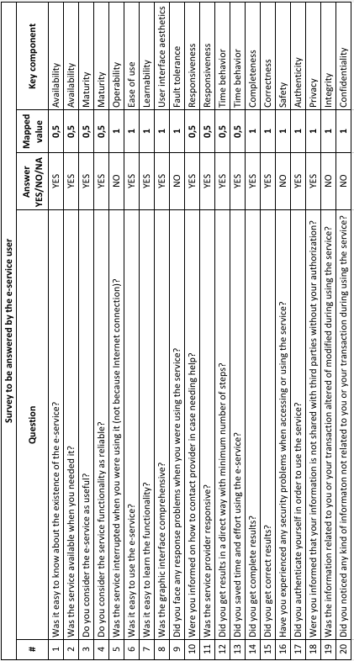

Figure 20 shows in colored squares in Part B the mapped values depicted on Table 6 considering the series of hypothesis on Figure 16 (Chapter 4-Part 8), which means the contributions among key components for Quality in use model.

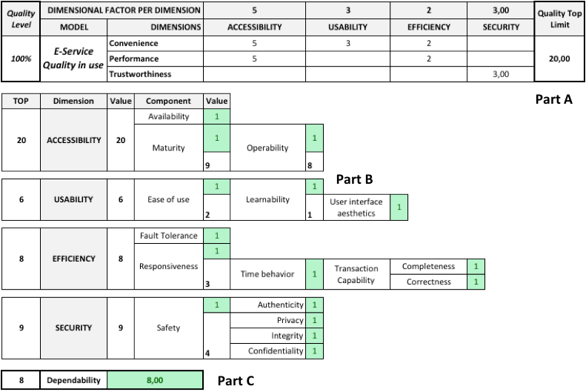

Figure 20. Mapped User survey values to Quality in use model (Best scenario)

In order to understand how Part B contains the mapped values from survey we proceed as follows:

Safety subindex value (4) is the sum of individual contributions of Authenticity (1), Privacy (1), Integrity (1), and Confidentiality (1), each was graded with 1 according to answers on the survey.

Right side value of Security dimension represents the sum of Safety subindex (4) plus each individual contribution to the dimension (5), this according to hypothesis **H4.8.6**, therefore the degree of **Security** dimension is **9**.

Completeness (1) plus Correctness (1), plus Time behavior (1) give the value 3 to Responsiveness subindex; adding that subindex, plus Responsiveness own value (1), plus Fault Tolerance (1), plus Time behavior (1) and Transaction capability (2) give the degree of **8** to **Efficiency** dimension, this according to hypothesis **H4.8.5**.

User interface aesthetics (1) contributes to Learnability subindex (1), this according to **H4.8.3**, plus Learnability subindex (1) plus its own value (1) contributes to Ease of use subindex value (2) , this according to **H4.8.2** give the degree of **6** to **Usability** dimension.

Operability subindex value (8) is result of adding Fault Tolerance (1) plus Responsiveness subindex (3) plus Responsiveness own value (1), plus Ease of Use subindex (2) and Ease of use own value (1), this according to hypothesis **H4.8.4**.

**H4.8.1** says Operability contributes to Maturity, this means Maturity subindex value is 9 because Operability subindex (8) plus its own (1).

**Accessibility** dimension value degree is **20**, because Maturity subindex (9) plus its own (1) plus Operability subindex (8) plus its own (1), plus Availability value (1).

### Conceptual model data results for quality in use model

Figure 20, Part A shows on DIMENSIONAL FACTOR PER DIMENSION field the degree value obtained on Part B for each dimension divided by the number of qualitative characteristics to which each dimension contributes.

Accessibility dimension has degree of 20, divided by 4 it contributes with value of 5 to Convenience and Performance (since them are in Quality in use model), this in conformance with Table 4 and Figure 17.

Usability degree (6) divied by 2 (Convenience and Functionality) contributes to Convenience with value of 3.

Efficiency degree (8) divided by 4 (Convenience, Performance, Compatibility, and Functionality) contributes only to Convenience and Performance with value of 2.

Security degree (9) divided by 3 (Trustworthiness, Compatibility, and Reliability) contributes only on Trustworthiness with value of 3.

Field “Quality Top Limit” with value 20, represents the sum of contributions per dimension, Accessibility (10), Usability (3), Efficiency (4) and Security (3).

Field “Quality Level” represents the percentage of quality level perceived by the user of an e-service.

### Dependability degree for quality in use model

In order to obtain Dependability degree for Quality in use model (Figure 18), values from Availability (1), Fault Tolerance (1), Safety (individual value) (1), Integrity (1), Confidentiality (1), and Trustworthiness (3) are added obtaining degree of **8** (Figure 20-Part C), which should be compared with Dependability degree from E-Service Product Quality model, the more close they are, the better, meaning that quality set by e-service provider was the quality preceived by the user. This helps to cover the Gap 1, Gap 2, and Gap 3 on Figure 1.

## Provider survey results mapped to proposed conceptual model

Table 7 shows the answers and the mapped values to the dimensional key components for ideal case which means the top level quality set to the e-service by the provider.

Table 7. Survey for e-service Provider (Best scenario)

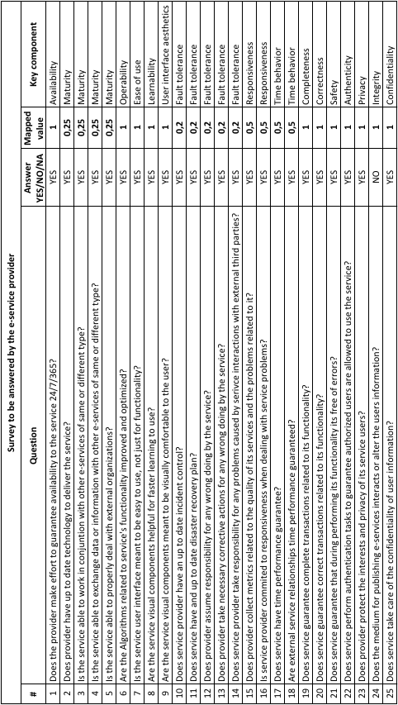

Figure 21 shows on colored sqaures in Part B the mappeed values depicted on Table 7 considering the series of hypothesis on Figure 16 (Chapter 4-Part 8), which means the contributions among key components, but for Product quality model.

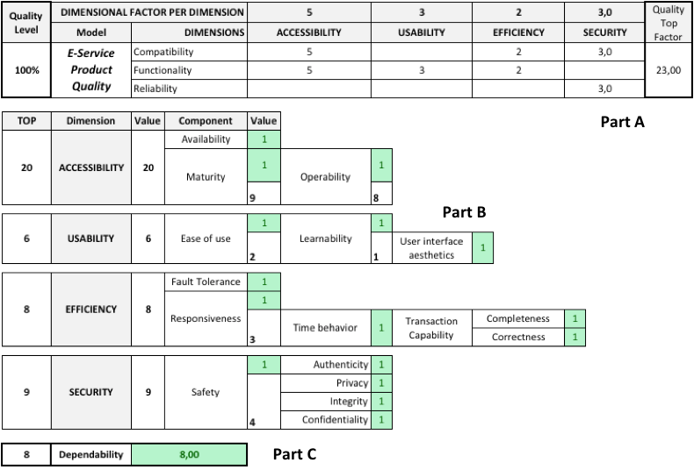

Figure 21. Mapped Provider survey values to Product quality model (Best scenario)

Procedure to get values in Figure 21-Part B is identical as in section **5.3.1**, since it is based on same proposed model (Figure 17) and hypothesis from Chapter 4-Part 8.

### Conceptual model data results for Product quality model

Contributions from Accessibility dimension (degree 20) to the E-service Product quality model correspond to Compatibility (5) and Functionality (5); contribution from Usability dimension (degree 6) corresponds to Functionality (3); contribution from Efficiency dimension (degree 8) corresponds to Compatibility (2) and Functionality (2); contribution from Security dimension (degree 9) corresponds to Compatiblity (3) and Reliability (3), all this in comformance with relationships depicted in Table 4 and Figure 17.

Field “Quality Top Limit” means the value of “Quality Level” can be equal (best scenario), but can not be greater; Quality Level as its name indicates, represents the percentage of quality level from the provider perspective of the e-service.

### Dependability degree for Product quality model

In order to obtain Dependability degree for Product quality model (Figure 18), values from Availability (1), Fault Tolerance (1), Safety (individual value) (1), Integrity (1), Confidentiality (1), and Reliability (3) are added obtaining degree of **8** (Figure 21-Part C), which should be compared with Dependability degree from E-Service Quality in use model, the more close they are, the better, meaning that quality set by e-service provider was the quality preceived by the user. This helps to cover the Gap 1, Gap 2, and Gap 3 on Figure 1.

## Scope

Set of questions meant for e-service user and provider surveys are the first approach for applying proposed model on Chapter 4, which is considered useful for understanding quality of e-services (in four dimensions – AUES) as individual unit of work and a composed e-service by other e-services. Estonian e-services were considered for this thesis work, nevertheless, model should be enough for understanding and evaluating qualitative characterisctis on e-services, which means when its used some other characteristics are necessary for better quality undertanding and evaluation.

## Limitations

Applying conceptual model from Chapter 4 and related surveys mighg not apply for all kind of e-services from all the industries, since the literature indicates that quality depends on different factors and perceptions, meaning sets of questions could not be either enough or some of them not apply, apporting false positive, or false negative results.

Next Chapter show results obtained from applying proposed conceptual model (Chapter 4) on selected Estonian e-services.

# Results and discussion

On this chapter, results of applying proposed model (Chapter 4) for understanding tue qulality of e-services in four dimensions AUES, using the methodology from Chapter 5-Part 3 are shown.

### Results for Estonian e-service 1: Digital Prescription

Survey for user was answered by 50 people

### Results for Estonian e-service 2: X-Road services for citizens via eesti.ee

## Discussion

# Conclusions and future work

On this chapter conclusions based on the experience along this thesis work are presented in conjunction with description of future work.

## Conclusions

In the age of the Internet where there are more and more new e-services there was a need of having a reference point ...

All the e-service quality evaluation methods should consider Accessibility, Usability, Efficiency and Security perspectives.

We agree with [8] on the fact that for each kind of e-service, it is still necessary to define the value dimensions and measures.

Most of current e-services are not matture in terms of quality.

Customers determine this qualitative characteristics in evaluating e-service quality regardless the type of service, other qualitative characteristics could be important in specific context and service objectives.

This thesis work has revealed that the AUES dimensions and its key components for each one ...

There are many other key components for AUES or another dimensions that are suitable for specific contexts, as part of future work they should be complemented to specific type of industry they are used in.

One of the fundamental values of e-services is to enable flexible business cooperation.

A conceptual model based on ISO/IEC 25010:2011 and part on differents studies was presented within this thesis work.

Definition for e-service given in Chapter 3, Part 2 can be considered as reference for s

## Future work

To develop a mesarement instrument to evaluate the quality of e-services based on the conceptual model presented on this thesis work.

To see how the ISO/IEC 25012 standard (model for data quality) could be a complement to this work remains as future work as well.

Quality assessment model and quality prediction model.

# References

x

|  |  |
| --- | --- |
| [1] | A. Parasuraman, V.A. Zeithaml, and L.L. Bery, "A conceptual model of service quality and its implications for future research," *Journal of Marketing*, vol. 49, no. 4, pp. 41-50, 1985. |
| [2] | Jukka Ojasalo, "E-service quality: A conceptual model," *Inernational Journal of Arts and Sciences*, vol. 3, no. 7, pp. 127-143, 2010. |
| [3] | Filipe Sá, Álvaro Rocha, and Manuel Pérez Cota, "Quality models of e-government online services," *IEEE International Conference on Computer and Information Technology*, 2014. |
| [4] | Kyriakos Kritikos et al., "A Survey on Service Quality Description," *ACM Computing Surveys*, vol. 46, no. 1, October 2013. |
| [5] | J. Santos, "E-service quality: a model of virtual service quality dimensions," *Managing service quality*, vol. 13, no. 3, pp. 233-246, 2003. |
| [6] | Mayte Herrera, Ma Ángeles Moraga, Ismael Caballero, and Coral Calero, "Quality in use model for web portals (QiUWeP)," n.d. |
| [7] | G. Piccinelli and E. Stammers, "From E-Processess to E-Networks: an E-Service-oriented approach". |
| [8] | E. Loukis, K. Pazalos, and A. Salagara, "Transforming e-services evaluation data into business analytics using value models," *Electronic Commerce Research and Applications*, vol. 11, pp. 129-141, 2012. |
| [9] | Egidijus Ostasius and Zivile Petraviciute, "Applying e-service model in assessment and comparison of services," pp. 443-450, 2010. |
| [10] | BSI Standards Publication. (2011) Systems and software engineering — Systems and software Quality Requirements and Evaluation (SQuaRE) — System and software quality models (ISO/IEC 25010). |
| [11] | Mohammed Ateeq, Ahmad Kamil, and Shuib Basri, "Conceptual model for measuring e-government service quality". |
| [12] | Hadi Teimouri, Shirin Rafiei Samani, Soroosh Emami, and Shiva Hamidipour, "Studying the key indicator of e-service quality in success of e-commerce," 2014. |
| [13] | J.E. Collier and C.C. Bienstock, "Measuring service quality in e-retailling," *Journal of Service Research*, vol. 8, no. 3, p. 260, 2006. |
| [14] | V.A. Zeithaml, "Service excellence in electronic channels," *Managing Service Quality*, vol. 12, no. 2, pp. 135-139, 2002. |
| [15] | Zeithaml, A. Parasuraman, and A. Malhotra, "A conceptual framework for understanding e-service quality: implications for future researches and managerial practice," MSI Working Paper Series No. 00-115, 2001. |
| [16] | J. Cox and B.G. Dale, "Service quality and e-commerce: An exploratory analysis," *Managing Service Quality*, vol. 11, no. 2, 2001. |
| [17] | Z. Yang, R.T. Peterson, and S. Cai, "Services quality diimensions of Internet retailing; an exploratory analysis," *Journal of services marketing*, vol. 17, no. 7, pp. 685-700, 2003. |
| [18] | M. Raman, R. Stephenaus, N. Alam, and M. Kuppusamy, "Information Technology in Malaysia: E-service quality and update of Internet banking," *Journal of Internet Banking and Commerce*, vol. 13, no. 2, pp. 1-18, 2008. |
| [19] | M.F. Wolfinbarger and M.C. Gilly, "ETAILQ: dimensionalizing, measuring and predicting etailing quality," *Journal of Retailing*, vol. 79, no. 3. |
| [20] | V.A. Zeithaml, A. Parasuraman, and A. Malhotra, "Service quality delivery through web sites: a critical review of extant knowledge," *Journal of the academy of marketing science*, vol. 30, no. 4, pp. 362-375, 2002. |
| [21] | B. Vanpariya and V. Patel, "Assessing electronic service quality through E-S-QUAL scale.". |
| [22] | G. Bresolles and J. Nantel, "The measurement of electronic service quality: Improvement and application," *Journal of E-Business Research*, vol. 4, no. 3, pp. 1-19, 2008. |
| [23] | G. Bresolles and F. Durrieu, "Service quality, customer value and satisfaction relationship revisited for online wine websites," in *6th AWBR International Conference, Bordeaux Management School*, 2011, pp. 9-10. |
| [24] | H. Li, Y. Liu, and R. Suomi, "Measurement of E-service Quality: An empirical study in online travel service," 2009. |
| [25] | H. Li and R. Suomi, "Dimensions of e-service quality: an alternative model," in *Future Generation Communication and Networking Symposia, Second International Conference*, vol. 1, 2008. |
| [26] | G.G. Lee and H.F. Lin, "Customer perceptions of e-service quality in online shopping," *International Journal of Retail ^Distribution Management*, vol. 33, no. 2, pp. 161-176, 2005. |
| [27] | N. Seth, S.G. Deshmukh, and P. Vrat, "A framework for measurement of quality of service in supply chains," *Supply chain management: An international journal*, vol. 11, no. 1, pp. 82-94, 2006. |
| [28] | ISO/IEC , "Systems and software engineering - Software product quality requirements and evaluation (SQuaRE)," *Software product quality and system quality in use models*, p. 25010.3, 2009. |
| [29] | Marion Lepmets, Antoni Lluís Mesquida, Aileen Cater-Steel, Antonia Mas, and Eric Ras, "The Evaluation of the IT Service Quality Measurement Framework in Industry," *Global Journal of Flexible Systems Management*, vol. 15, no. 1, pp. 39-57, March 2014. |
| [30] | Zhao Huang and Morad Benyoucef, "From e-commerce to social commerce: A close look at the design features," *Electronic Commerce Research and Applications*, vol. 12, pp. 246-259, 2013. |
| [31] | R. Ladhary, "Developing e-service quality scales: A literature review," *Journal of retailing and consumer services*, vol. 17, pp. 464-477, 2010. |
| [32] | A. Al-Shehry M., "Transformation towards e-government in kingdom of Saudi Arabia: Technological and organisational perspectives," 2008. |
| [33] | Owen Eriksson and Goldkuhl Göran, "Preconditions for public sector e-infrastructure development," *Information and Organization*, vol. 23, pp. 149-176, June 2013. |
| [34] | H. Li and R. Suomi, "A proposed scale for measuring e-service quality," *International Journal of u-and e-service, Science and Technology*, vol. 2, no. 1, pp. 1-10, 2009. |
| [35] | Demetrios Sarantis, Christos Tsiakaliaris, Fenareti Lampathaki, and Yannis charalabidis, "A Standardization Framework for Electronic Government Service Portals," 2009. |
| [36] | C. Halaris, B. Magoutas, X. Papadomichelaki, and G. Mentzas, "Classification and synthesis of quality approaches in e-government services," *Internet Reseach*, vol. 17, no. 4, pp. 378-401, 2007. |
| [37] | C.W. Tan, I. Benbasat, and R.T. Cenfetelli, "Building citizen trust towards E-government services: Do high quality websites matter?," *The 41st Hawaii International Conference on System Sciences*, p. 217. |
| [38] | Naelah Al-Dabbous, Anwar Al-Yatama, and Kassem Saleh, "Assessment of the trustworthiness of e-service providers," 2011. |
| [39] | M. Fassnacht and I. Kose, "Coinsequences of web based service quality: uncovering a multifaceted chain of effects," *Journal of Interactive Marketing*, vol. 21, no. 3, pp. 33-54, 2007. |
| [40] | Iham Tariq, Ahmad Kamil, and Hamid Jebur, "Proposed conceptual model for e-service quality in Malaysian universities," 2014. |
| [41] | B. Yoo and N. Donthu, "Developing a scale to measure the perceived quality of an internet shopping site (SITEQUAL)," *Quarterly journal of Electronic Commerce*, vol. 2, no. 1, pp. 31-46, 2001. |
| [42] | M. Kim, J.-H. Kim, and S.J. Lennon, "Online service attributes available on apparel retail web sites: an E-S-QUAL approach," vol. 16, no. 1, pp. 51-77, 2006. |
| [43] | A. Parasuraman, V.A. Zeithaml, and A. Malhotra, "E-S-Qual: a multiple item scale for assessing electronic service quality," *Journal of Service Research*, vol. 7, no. 3, pp. 213-233, 2005. |
| [44] | K. Wachter, "Longitudinal assessment of web retailers: issues from a consumer point of view," *Journal of Fashion Marketing & Management*, vol. 6, no. 2, pp. 134-45, 2002. |
| [45] | Z. Yang and X. Fang, "Online service quality dimensions and their relationships with satisfaction: a content analysis of customer reviews of securities brokerage services," *International Journal of Service Industry Management*, vol. 15, no. 3, pp. 302-326, 2004. |
| [46] | Z. Yang and M. Jun, "Consumer perception of e-service quality: from Internet purchaser and non-purchaser perspectives," *Journal of Business Strategies*, vol. 19, no. 1, pp. 19-41, 2002. |
| [47] | M.C. Obi, "Cevelopment and validation of a scale for measuring e-government user satisfaction," 2009. |
| [48] | International Telecommunication Union, "Specifications of signalling system No. 7 - Transaction capabilities application part," Telecoomunication Standardization Sector of ITU, International Telecommunication Union, 1998. |
| [49] | Tsuen-Ho Hsu, Li-Chu Hung, and Jia-Wei Tang, "A hybrid ANP evaluation model for electronic service quality," *Applied Soft Computing*, vol. 12, pp. 72-81, 2012. |
| [50] | Mohammed Ateeq, Ahmad Kamil, and Shuib Basri, "A porposed model for assessing e-government service quality: An E-S-QUAL Approach," 2012. |
| [51] | Aline Chiabai, Lorena Rocca, and Livio Chiarullo, "A service quality model for web-services evaluation in cultural heritage management," pp. 227-242, 2011. |
| [52] | Hunk-Jen Tu and Yuan-Ting Chaoo, "Toward a framework for assessing e-marketplace service quality," pp. 36-43, 2011. |
| [53] | Daniel Oberle, Alistair Barros, Uwe Kylau, and Steffen Heinzl, "A unified description language for human to automated services," *Information Systems*, vol. 38, pp. 155-181, 2013. |
| [54] | M. Kim J.H. Kim and J. Kandampully, "Buying environment characteristics in the context of e-service," *European Journal of Marketing*, vol. 43, no. 9/10, pp. 1188-1204, 2009. |
| [55] | R. Vidgen and S. Barnes, "An integrative approach to the assessment of e-commerce quality," *Journal of Electronic Commerce Research*, vol. 3, no. 3, pp. 114-127, 2002. |
| [56] | A. Parasuraman, V.A. Zeithaml, and L.L. Berry, "SERVQUAL: a multiple-item scale for measuring consumer perceptions of service quality," *Journal of Retailing*, vol. 64, pp. 12-40, 1988. |
| [57] | E. Cristobal, C. Flavian, and M. Guinaliu, "Perceived e-service quality (PeSQ): measurement validation and effects on consumer satisfaction and web site loyalty.," *Managing Service Quality*, vol. 17, no. 3, pp. 317-340, 2007. |
| [58] | J. Kim and J. Lee, "Critical design factors for successful e-commerce systems," *Behaviour and information technology*, vol. 21, no. 3, pp. 185-9, 2002. |
| [59] | C. Rangnathan and C. Ganapathy, "Key dimensions of business-to-consumer web sites," *Information and Management*, vol. 39, pp. 457-465. |

x

Appendix A

1. Glossary

|  |  |
| --- | --- |
| Attribute  Inherent property or characteristic of an entity that can be distinguished quantitatively or qualitatively by human or automated means [10]. | Sisestusmärk  Märk, mis märgib teksti sisestamise asukohta. |
| User  Individual or group that interacts with a system or benefits from a system during its utilization [10]. | Mall  Näidik, muster või valuvorm, mis esitab täitmisele võetava töö struktuuri. |
| Quality property  Measurable component of quality [10]. |  |
| Quality Model  Defined set of characteristics, and of relationships between them, which provides a framework for specifying quality requirements and evaluating quality [10]. |  |

1. License

**Non-exclusive licence to reproduce thesis and make thesis public**

I, **Israel Cuautle Muñoz** (date of birth: 16.05.1984),

(*author’s name*)

1. herewith grant the University of Tartu a free permit (non-exclusive licence) to:

1.1. reproduce, for the purpose of preservation and making available to the public, including for addition to the DSpace digital archives until expiry of the term of validity of the copyright, and

1.2. make available to the public via the web environment of the University of Tartu, including via the DSpace digital archives until expiry of the term of validity of the copyright,

of my thesis

**Understanding the Quality of e-Services: Accessibility, Usability, Efficiency and Security.**,

*(title of thesis)*

supervised by Raimundas Matulevičius, PhD,

*(supervisor’s name)*

2. I am aware of the fact that the author retains these rights.

3. I certify that granting the non-exclusive licence does not infringe the intellectual property rights or rights arising from the Personal Data Protection Act.

Tartu, **23.08.2016**

1. http://www.businessdictionary.com/definition/services.html
2. http://its.yale.edu/news/itil-foundations-what-service
3. http://its.ucsc.edu/itsm/servicemgmt.html
4. <http://www.investorwords.com/1637/e_commerce.html>
5. http://www.slideshare.net/rp-blog/measuring-online-service-quality-the-case-of-localegovernment
6. http://iso25000.com/index.php/en/iso-25000-standards/iso-25010?limit=3&start=3
7. http://iso25000.com/index.php/en/iso-25000-standards/iso-25010?limit=3&start=3
8. http://iso25000.com/index.php/en/iso-25000-standards/iso-25010
9. http://iso25000.com/index.php/en/iso-25000-standards/iso-25010?limit=3&limitstart=0
10. http://iso25000.com/index.php/en/iso-25000-standards/iso-25010?limit=3&start=6